AIG Distribution Portal
Functional Specifications Document
Version 0.1

TABLE OF CONTENTS

1 Document Title 5
2 Revision History 5
3 Review and Approval 5
4 Introduction 5
4.1 Document Purpose 5
4.2 Scope 5
4.3 Intended Audience 5
4.4 Related Documents 6
5 General Considerations 6
5.1 Assumptions and Dependencies 6
A) Assumptions 6
B) Dependencies 6
5.2 Risks and Volatile Areas 6
6 Functional Specifications 7
6.1 Registration and login 7
6.1.1 Sub Function1: Registration 7
6.1.1.1 Business Rules 7
6.1.1.2 UI 7
6.1.1.3 Field Specifications 7
6.1.2 Sub Function2: Login 7
6.1.2.1 Business Rules 7
6.1.3 Sub Function3: Change the password 8
6.1.3.1 Business Rules 8
6.1.3.2 UI 8
6.1.3.3 Field Specifications 8
6.1.4 Sub Function4: Forget User ID/ Password 8
6.1.4.1 Business Rules 8
6.1.4.2 UI 8
6.1.4.3 Field Specifications 8
6.2 Overview Page 9
6.2.1 Sub Function1: Overview page 9
6.2.1.1 Business Rules 9
6.2.1.2 UI 12
6.2.1.3 Field Specifications 12
6.3 Mine Information 12
6.3.1 Sub Function 1: My Information 12
6.3.1.1 Business Rules 13
6.3.1.2 UI 13
6.3.1.3 Field Specifications 13
6.3.2 Sub Function 2: My President Conference campaign 13
6.3.2.1 Business Rules 13
6.3.2.2 UI 14
6.3.2.3 Field Specifications 14
6.4 Team Member’s information 14
6.4.1 Sub Function 1: Team Member’s information 14
6.4.1.1 Business Rules 14
6.4.1.2 UI 14
6.4.1.3 Field Specifications 14
6.4.2 Sub Function 2: Team member’s President Conference campaign 14
6.4.2.1 Business Rules 15
6.4.2.2 UI 16
6.4.2.3 Field Specifications 16
6.5 Submission statistics 16
6.5.1 Sub Function 3: Submission statistics 16
6.5.1.1 Business Rules 17
6.5.1.2 UI 19
6.5.1.3 Field Specifications 19
6.6 Premium Statistics 19
6.6.1 Sub Function 1: Premium Income report 19
6.6.1.1 Business Rules 19
6.6.1.2 UI 21
6.6.1.3 Field Specifications 21
6.6.2 Sub Function 2: Premium receivable list 21
6.6.2.1 Business Rules 22
6.6.2.2 UI 24
6.6.2.3 Field Specifications 24
6.7 Policy Inquiry 24
6.7.1 Sub Function 1: Policy Inquiry 24
6.7.1.1 Business Rules 25
6.7.1.2 UI 26
6.7.1.3 Field Specifications 26
6.8 Sales Support 27
6.8.1 Sub Function 1: Product information 27
6.8.1.1 Business Rules 27
6.8.1.2 UI 27
6.8.1.3 Field Specifications 27
6.8.2 Sub Function 2: Documents for sales practices 27
6.8.2.1 Business Rules 27
6.8.2.2 UI 28
6.8.2.3 Field Specifications 28
6.9 Online Training 28
6.9.1 Sub Function 1: Online Training 28
6.9.1.1 Business Rules 28
6.9.1.2 UI 28
6.9.1.3 Field Specifications 28
6.10 Management & Statistic uploading 28
6.10.1 Sub Function 1: User management 28
6.10.1.1 Business Rules 29
6.10.1.2 UI 31
6.10.1.3 Field Specifications 31
6.10.2 Sub Function 2: Notification Management 31
6.10.2.1 Business Rules 32
6.10.2.2 UI 32
6.10.2.3 Field Specifications 32
6.10.3 Sub Function 3: President Conference campaign uploading 32
6.10.3.1 Business Rules 33
6.10.3.2 UI 33
6.10.3.3 Field Specifications 33
6.10.4 Sub Function 4: Submission Statistics uploading 33
6.10.4.1 Business Rules 34
6.10.4.2 UI 35
6.10.4.3 Field Specifications 35
6.10.5 Sub Function 5: Premium receivable list uploading 35
6.10.5.1 Business Rules 35
6.10.5.2 UI 36
6.10.5.3 Field Specifications 36
6.10.6 Sub Function 6: Product & Successes story uploading 36
6.10.6.1 Business Rules 36
6.10.6.2 UI 36
6.10.6.3 Field Specifications 36
6.10.7 Sub Function 7: Sales support document uploading 37
6.10.7.1 Business Rules 37
6.10.7.2 UI 37
6.10.7.3 Field Specifications 37
6.10.8 Sub Function 8: Online training uploading 37
6.10.8.1 Business Rules 37
6.10.8.2 UI 37
6.10.8.3 Field Specifications 38
7 Non Functional Specifications 38
1) Language 38
2) Time Zone 38
3) Browsers 38
4) Concurrency 38
8 Requirement Traceability Matrix 38

Document Title

AIG China Distribution Portal Functional Specification Document

Revision History

Date | Version | Modified By: | Description of Change
03-09-2018 | Version 0.1 | Echo Jia | Initial Version

Review and Approval
If appropriate, this section contains formal sign-off for both review and approval of this document.
- Approval History
Approving Party | Designation | Version Approved | Signature | Date

- Review History
Reviewing Party | Designation | Version Reviewed | Signature | Date

Introduction

Document Purpose
The functional specifications document is intended to document the results of the analysis of every requirement in BRD (China Distribution Portal_BRD_V1.0). It defines the benchmark of the portal’s design and development.

Scope
This document is developed upon the BRD document “China Distribution Portal_BRD_V1.0” including the embedded non-functional requirements.

Intended Audience
- AIG project team
- AIG related business users
- Cognizant Distribution Portal project team
- Other AIG authorized vendors

Related Documents
- Related and/or companion documents
- Prerequisite documents
- Documents which provide background and/or context for this document
- Documents that result from this document (e.g. a test plan or a development plan)

Ref # | Document | Location | Author | Version
1 | China Distribution Portal_BRD_V1.0 | Local | AIG Cathy Xie | V 1.0

General Considerations

Assumptions and Dependencies

Assumptions
  - AIG will provide email sending interface/or related configuration information.
  - All page will be responsive based on phone/pc device, most pages only have one layout style. But for “Team member’s president conference campaign”, “Submission statistics”, “Premium statistics” and “Policy inquiry” module will support different styling for PC & mobile.
  - Front end function and admin function will be in the same code solution, so from deployment perspective those functions needn't deployed separately.
  - the statistic number will be uploaded from file, so that front end application needn't calculate the statistic. The only task for front end application is to show the graph based on the statistic uploaded.
  - The distribution portal will not integrate with IAM the portal.
  - Share function is only supported in Mobile platform. For current phase, the portal need supports to share name card by image-text version to Wechat Moment and Wechat friend only. Sharing to QQ/ Weibo is default use mobile browser to share.
  - AIG will provide a WeChat public account.
  - AIG need provide SQL to fetch premium income list & policy details from GoalD.
  - Browser compatibility only support latest version in these two years.
  - Admin functional support PC only

Dependencies

Risks and Volatile Areas

Functional Specifications

Registration and login

Sub Function1: Registration

Sub Function Name | Registration
Brief Description | This sub function enables the user to register account .
Actor(s) | Users
Pre-Conditions | The actor open login page .
Flow of Events | Normal Flow:
Flow of Events | - Actor should click [注册]in login page, registration page will pop up.  - Actor should input account ID, name, branch, position, employee No., contact No. and email account before click [注册].  - After actor click [注册], the portal will check if the information is not blank, not duplication and correct  - After check information and submit successfully, jump to login page.  - The portal should trigger an email to admin user to notice admin user to activate the user.  - After admin user activates the user, the account ID will be active and the account ID/initial password will be received through email to actor.  - The flow end
Flow of Events | Alternate Flow / Exceptions:
Flow of Events | Alternative flow 1: If. registration information duplication  - Step 1-2 is same  - If actor input duplication registration information, the portal will display an error message as “此用户已存在”  - If registration information is correct, actor will successfully register  - The flow end
Flow of Events | Extensions:
Flow of Events | None
Post-Condition | Successfully registered

Business Rules
- <Registration >page will contain six input box, three drop down list and two button. Page details refer to UI registration page, and 6.1.1.3 Field Specifications.

- When user click [注册] in registration page, the portal will check if all mandatory fields are correct.
- If any mandatory field is null, there will display an error like “请输入XXXXX”
- If user input correct information, there will display an error like “请正确输入XXXXX”.
- If user input duplicate employee id, there will display an error like “此用户已存在”.

- Only pass all check rules, the portal will save information into DB and trigger email. If user close the window below pass all rules, the registration information will not be reserved.

- Employee id will be the major key of a user account.

- Once the actor submits the registration, <Registration > page will turn to message page. Message as “ 注册信息已提交，请等待管理员激活账号”.

- When actor submit registration, the portal will create a record to store the registration information in DB and trigger an email immediately to user. Format is as below:
  - To: account@aig.com
  - Subject: [Distribution portal] register account
  - Content:

The user has applied a distribution portal account, please help active the user account.
Username | Employee ID

--------------------------------------------------------
This is an automatically generated message. Please do not reply.

- If email sending is failed, the record will be marked as “failed”. The portal record an error log and will run a batch to resend all failed records one by one at midnight every day (configurable).

UI
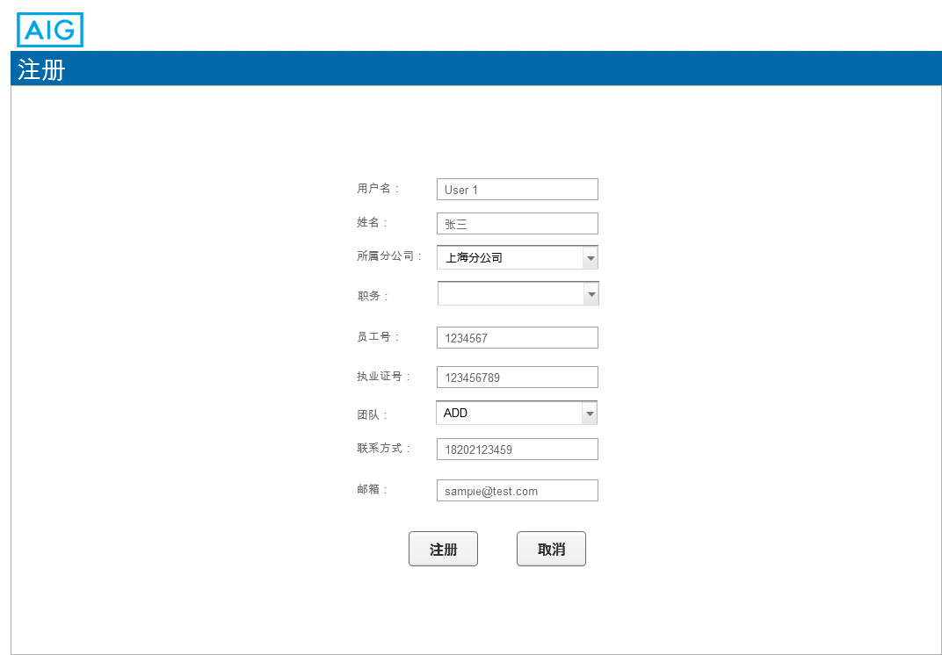
6.1.1_1 registration page

Field Specifications
Field Name | Type | Dropdown List Content | Mandatory | Attribute (Editable/Read Only) | Validation | Remark
用户名 | Text | NA | Yes | Editable | 50个字符内的中文或英文 | Account ID
姓名 | Text | NA | Yes | Editable | 10个字符内的中文或英文 | Name
所属分公司 | Dropdown list | 上海分公司/广东分公司/深圳分公司/北京分公司/江苏分公司/浙江分公司 | Yes | Editable |  | Branch
职务 | Dropdown list | 职员/ 组长/ 组长助理/ 分公司经理/ CHO/CDO/OP Manager/ 管理员 | Yes | Editable |  | Position
员工号 | Text | NA | Yes | Editable | 10个字符内的数字 | Employee No.
联系方式 | Text | NA | Yes | Editable | 手机号校验 | Contact No.
邮箱 | Text | NA | Yes | Editable | 邮箱格式校验 | Email account
注册 | Button | NA | NA | Read Only |  | Submit
执业证号 | Text | NA | Conditional mandatory | Editable |  | Agent qualification No.
团队 | Dropdown list | ADD/DS/CBE | Conditional mandatory | Editable | Optional for CDO/CHO/Op manager/Branch GM | Team

Sub Function2: Login

Sub Function Name | Login
Brief Description | This sub function enables the user to login.
Actor(s) | Users
Pre-Conditions | The actor open login page .
Flow of Events | Normal Flow:
Flow of Events | - After actor input account ID and password in login page and click [登录], the portal will check if the account ID and password is correct  - If check pass, the portal will check the login password is initial password or not.  - If it is not, overview page will display. If it is, the change password page will display.  - The flow end
Flow of Events | Alternate Flow / Exceptions:
Flow of Events | NA
Flow of Events | Extensions:
Flow of Events | None
Post-Condition | Successfully login.

Business Rules
- <Login> page will contain two input box to input account ID and password, two button and a link. When user input password, the password will be encrypted by “*”.

- When user click [登录], the portal will check if account id and password are correct.
- If account is not active, there will display an error like “此用户未激活”
- If account is non-existent, there will display an error like “此用户不存在”
- If any mandatory field is null, there will display an error like “请输入用户名/密码”
- If account is active, actor input the account ID or password is wrong, the portal will display error like “用户名\密码错误” then empty the values.

- After check pass, the portal will check the login password is initial password or not.
  - If it is not, overview page will display.
  - If it is, the change password page will display.

- When user click [注册] in login page, the registration page will display.

- When user click “forget account/password” link, the recover account/password page will display.

UI
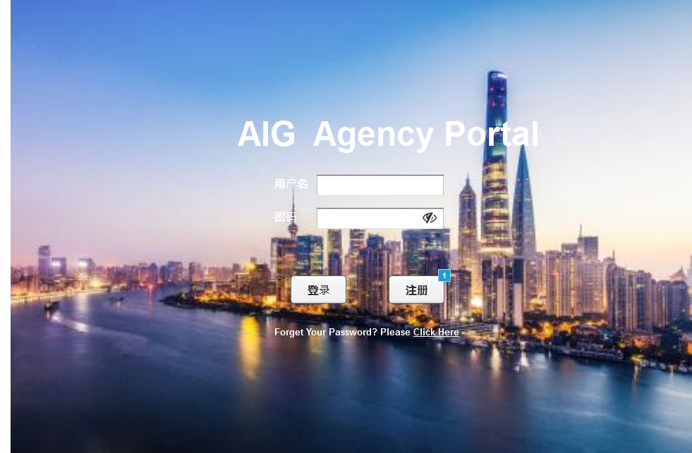
6.1.2 _1 login page

Field Specifications
Field Name | Type | Dropdown List Content | Mandatory | Attribute (Editable/Read Only) | Validation | Remark
用户名 | Text | NA | Yes | Editable | 1.非空校验  2.格式校验 | Account ID
密码 | Text | NA | Yes | Editable | 1.非空校验  2.格式校验 | Password

Sub Function3: Change the password
Sub Function Name | Change the password
Brief Description | This sub function enables the user to change the password.
Actor(s) | Users
Pre-Conditions | The actor have registered.
Flow of Events | Normal Flow:
Flow of Events | - When actor login with initial password, the portal should display a message as “请修改密码”  - Actor should change the password  - If actor login with password and want to change password, actor could click link “更改密码”, change password page should display  - User need to enter the old password first, the portal will check if the password matches the account  - Then enter the new password twice, the portal will check if the two new password are same  - Then actor change the password  - The flow end
Flow of Events | Alternate Flow / Exceptions:
Flow of Events | Alternative flow 1: If. the old password is wrong  - Step1-3 is the same  - The portal will check the old password is correct or not  - If the old password is wrong, there will display an error message as “密码与账户不一致”  - Actor input the password again  - After check pass, the portal allow actor to input new password  - The flow end  Alternative flow 1: If. the two new password are not same  - Step1-4 is the same  - The portal will check if the two new password entered are same  - If the two password is not same, there will display an error message as “密码不一致，请再输一遍”  - When two passwords are same, password change successfully  - The flow end
Flow of Events | Extensions:
Flow of Events | None
Post-Condition | Actor change password successfully.

Business Rules
- <change password>page please refer to UI. When user change password, the portal will do the following check.
- When user input old password, the portal will check if the old password is match the account. If not, the portal will display error like “密码与账户不一致”.
- When user input new password, the portal will check if the new password is follow the AIG rules. If not, the portal will display error like “密码格式有误，请重新输入”.
- When user click [ 确认], the new password will be update into the portal DB.
- When user enter blank, the portal will display error like “请输入密码”.
- If user input confirm new password, the portal will check if two new passwords is same. If not, the portal will display an error message like “输入密码有误，请重新输入”.

- Changing the password is divided into two situations.
- When login with initial password, user need change password at the first time. The portal will display a change password page to force user change password. User cannot operate other page before change password.
- When login with modified password, user can change the password at any time. After click the link “更改密码” at the top right of the page, change password page will display. After actor change the password, actor should login with new password again

- Password need follow AIG standard:
  - At least 8 characters.
  - Passwords must include characters from at least three of the following five sets of characters: lower case alphabetic, upper case alphabetic, numeric values, unicode, and special characters (e.g. @, #, $).
  - Be unique to the previous 13 passwords and initial password.
  - Be restricted to one change within a 24 hour period except for one-time-password implementations where technically possible.
  - Not be programmed into "remember password" features, scripts or function keys.
  - User account passwords must be changed every 90 days.
  - Maximum number of 6 consecutive failed login attempts, after which the user’s access must be suspended for a minimum of 30 minutes or until reset by an administrator.
  - Store and transmit passwords in protected (e.g., encrypted or hashed) form.
  - Password resets performed by Help Desk or administrator must be temporary (i.e., enforce that the user must then change the temporary password at initial logon), enforced as technically possible.
  - Before a password is changed, the current password must be entered unless reset automatically (system-generated) or by a security/system administrator, as currently supported and technically possible.
  - Password must be masked or otherwise obscured during entry by the user.

UI
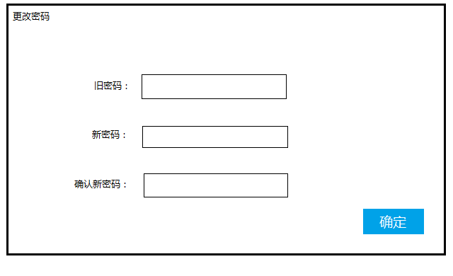
7.1.2.2_1 change password page

Field Specifications
Field Name | Type | Dropdown List Content | Mandatory | Attribute (Editable/Read Only) | Validation | Remark
旧密码 | Text | NA | Yes | Editable | 1.非空校验  2.格式校验 | Old password
新密码 | Text | NA | Yes | Editable | 1.非空校验  2.格式校验 | New password
确认新密码 | Text | NA | Yes | Editable | 1.非空校验  2.格式校验 | Confirm new password

Sub Function4: Forget the user ID/password
Sub Function Name | Forget the user ID/password
Brief Description | This sub function enables the user to recover the user ID/password.
Actor(s) | Users
Pre-Conditions | The actor have registered.
Flow of Events | Normal Flow:
Flow of Events | - If actor forget account/password, “click here” link will be click in the login page  - After that, a page should display for actor to input email and employee id, the portal will check actor's email and name is correct or not.  - After check actor's email and name, the portal should send username & initial password to user through email  - The flow end
Flow of Events | Alternate Flow / Exceptions:
Flow of Events | NA
Flow of Events | Extensions:
Flow of Events | None
Post-Condition | Actor get account ID& initial password successfully.

Business Rules
- <Forget> page please refer to UI. After user click the link “forget password/account” in <login> page, <forget> page will display. When user click [确认] to submit email and employee id, the portal will do the following check.
- When user input email and name, if email is not match name, the portal will display error like “邮箱与员工号不匹配”. If the employee id is not register, the portal will display error like “此用户不存在”.
- When field is null, the portal will display error like “请输入姓名或邮箱”

- When user id and new password send to user, new password will update in the portal BD and old password will invalid.

- After check pass, the portal should trigger email to send user’ password. Format is as below:
To: recoverpassword@aig.com
Subject: [Distribution Portal] Forget password & ID
Content:

Please user your initial password to login. For your account security, please change your password immediately after login.

Username | Initial password
 | Password!

--------------------------------------------------------
This is an automatically generated message. Please do not reply.

- If email sending is failed, the record will be marked as “failed”. The portal will run a batch to resend all failed records one by one at midnight every day (configurable).

UI
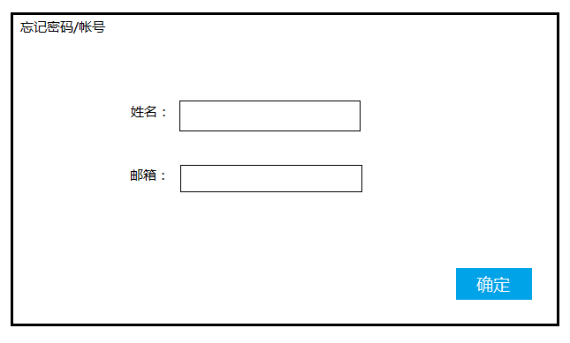
6.1.4_1 forget page

Field Specifications
Field Name | Type | Dropdown List Content | Mandatory | Attribute (Editable/Read Only) | Validation | Remark
邮箱 | Text | NA | Yes | Editable | 1.非空校验  2.格式校验 | Name
姓名 | Text | NA | Yes | Editable | 1.非空校验  2.格式校验 | Email account

Overview Page

Sub Function1: Overview page
Sub Function Name | Overview Page
Brief Description | After user login, the first page will be overview page. User could view some personal/ team brief information here and some information notifications.
Actor(s) | User
Pre-Conditions | User need login the distribution portal.
Flow of Events | Normal Flow:
Flow of Events | - User login the distribution portal.  - The Home page of Distribution Portal is <overview page>  - User could found the menu is at the left part of this page, his/her brief information is at the middle part and. And at the top part of this page will display some notifications.
Flow of Events | Alternate Flow / Exceptions:
Flow of Events | NA
Flow of Events | Extensions:
Flow of Events | None
Post-Condition

Business Rules
- <Overview page> will contain 3 parts:
  - Top part functions include:
    - “您好，xx” will display on the top right side of the page. XX is the username of the user.
    - Change the password: When user click this function, <change the password> page will pop up.
    - Logout: When user click this function, the portal will turn to <Login> page.

  - Left part display the menus. But for different user, the Portal will hide some menus base on different position. The relationship between menu and position is as below:
Menu |  | Position
Level 1 | Level 2 | Staff (ADD/DS/CBE) | Assistant | Team Manager | GM | CHO/CDO/OP Manager | Admin
Overview |  | Y | Y | Y | Y | Y | Y
Mine | My information | Y | Y | Y | Y | Y | Y
Mine | My president conference campaign | Only for ADD & DS team | N | N | N | N | N
Team | Team member’s information | N | Y | Y | Y | Y | Y
Team | Team member’s president conference campaign | N | Only for ADD & DS team | Only for ADD & DS team | Y | Y | Y
Submission Statistics |  | Y | Y | Y | Y | Y | Y
Premium Statistics | Premium Income Report | Y | Y | Y | Y | Y | Y
Premium Statistics | Premium Receivable list | Y | Y | Y | Y | Y | Y
Policy Inquiry |  | Y | Y | Y | Y | Y | Y
Sales Support | Product information | Y | Y | Y | Y | Y | Y
Sales Support | Documents for Sales practices | Y | Y | Y | Y | Y | Y
Online Training |  | Y | Y | Y | Y | Y | Y
Management & Statistic Uploading(PC only) | User Management | N | N | N | N | N | Y
Management & Statistic Uploading(PC only) | Notification Setting | N | N | N | N | N | Y
Management & Statistic Uploading(PC only) | President Conference Campaign uploading | N | Y | N | N | N | Y
Management & Statistic Uploading(PC only) | Submission Statistics Uploading | N | Y | N | N | N | Y
Management & Statistic Uploading(PC only) | Premium Receivable list uploading | N | Y | N | N | N | Y
Management & Statistic Uploading(PC only) | Product & success story uploading | N | N | N | N | N | Y
Management & Statistic Uploading(PC only) | Sales support document Uploading | N | N | N | N | N | Y
Management & Statistic Uploading(PC only) | Online Training uploading | N | N | N | N | N | Y
Management & Statistic Uploading(PC only) | Exchange rate setting | N | N | N | N | N | Y

  - The Middle part: will show the user’s information and some brief information of the user or user’s team, and the notifications.
    - Notification: After some notification uploaded into the portal and be enabled, the notifications will display as scroll bar at overview page. Time interval between 2 notifications is 3 seconds (configurable). Display sequence should be based on the updating date & time. The nearest one will at the first sequence.
    - User’s information:
Field name | Description
Name | The user’s name.
Branch | The user’ branch.
Position | The user’ position.
Team | The user’ team.
Producer code/Sub code | When user team is “DS”, producer code/Sub code =producer code  When user team is “ADD” or “CBE”, producer code/Sub code =producer sub code  Others will be null.

    - Brief information:
      - When the user’s position is “staff”, they will view their own brief information. The content is as below:
Field name | Description
YTD Premium booking | Use the user’s employee id to fetch the newest (which means the report date is the newest one) “YTD premium booking” in premium income report.
MTD Premium booking | Use the user’s employee id to fetch the newest “YTD premium booking” in premium income report.
YTD Submission Number | Use the user’s employee id to fetch his/her submissions which the “Financial Year”(in submission statistic) is the current year. And display the total amount of the submissions.
Over 90 days outstanding premium | Use the user’s employee id and “overdue period” is “under 90 days”(in premium receivable table) to fetch outstanding premium. The portal need summarize the “booked premium” and trans to CNY.
Over 120 days outstanding premium | Use the user’s employee id and “overdue period” is “under 120 days” to fetch outstanding premium. The portal need summarize the “booked premium” and trans to CNY.
Premium rank in team | Use the user’s employee id to fetch his premium rank in team.

      - When the user’s position is “Manager/ Assistant”, they will view their team’s brief information. The content is as below:
Field name | Description
Team YTD Premium booking | Use the user’s team to fetch the team’s newest “YTD premium booking” in premium income report.
Team MTD Premium booking | Use the user’s team to fetch the team’s newest “MTD premium booking” in premium income report.
Team YTD Submission Number | Use the user’s team to fetch the team’s submissions which the “financial year” is the current year. And display the total amount of the submissions.
Team Over 90 days outstanding premium | Use the user’s team and “overdue period” is “under 90 days” to fetch outstanding premium. The portal need summary the “booked premium” and trans to CNY.
Team Over 120 days outstanding premium | Use the user’s team and “overdue period” is “under 120 days” to fetch outstanding premium. The portal need summary the “booked premium” and trans to CNY.
Premium rank among all team | Use the user’s team to fetch his premium rank among all teams.
Note: When the user is Assistant, the portal need found all users whose “assistant” is the login user and summarize their statistics according to the field logic.

      - When the user’s position is “Branch GM”, they will view their branch’s brief information. The content is as below:
Field name | Description
Branch YTD Premium booking | Use the user’s Branch to fetch the newest “YTD premium booking” in premium income report.
Branch MTD Premium booking | Use the user’s Branch to fetch the newest “YTD premium booking” in premium income report.
Branch YTD Submission Number | Use the user’s Branch to fetch his/her submissions which the “financial year” is the current year. And display the total amount of the submissions.
Branch Over 90 days outstanding premium | Use the user’s Branch and “overdue period” is “under 90 days” to fetch outstanding premium. The portal need summary the “booked premium” and trans to CNY.
Branch Over 120 days outstanding premium | Use the user’s Branch and “overdue period” is “under 120 days” to fetch outstanding premium. The portal need summary the “booked premium” and trans to CNY.
Premium rank among all branch | Use the user’s branch to fetch his premium rank among all branches.

      - When the user’s position is “CHO/CDO/ OP Manager”, they will all branch’s brief information. The content is as below:
Field name | Description
All Branch YTD Premium booking | Summarize all employee’s the newest “YTD premium booking” in premium income report.
All Branch MTD Premium booking | Summarize all employee’s the newest (which means the report date is the newest one) “MTD premium booking” in premium income report.
All Branch YTD Submission Number | Summarize all employee’s submissions which the “financial year” is the current year. And display the total amount of the submissions.
All Branch Over 90 days outstanding premium | Summarize all employee’s outstanding premium which “overdue period” is “under 90 days”. The portal need summary the “booked premium” and trans to CNY.
All Branch Over 120 days outstanding premium | Summarize all employee’s outstanding premium which “overdue period” is “under 120 days”. The portal need summary the “booked premium” and trans to CNY.
Premium rank among all branch

      - When the user’s position is “Admin”, they will not have this part.

- For this page, PC & mobile will use the same display. Page will be auto adaptive to the device size.

UI
Need update by UI
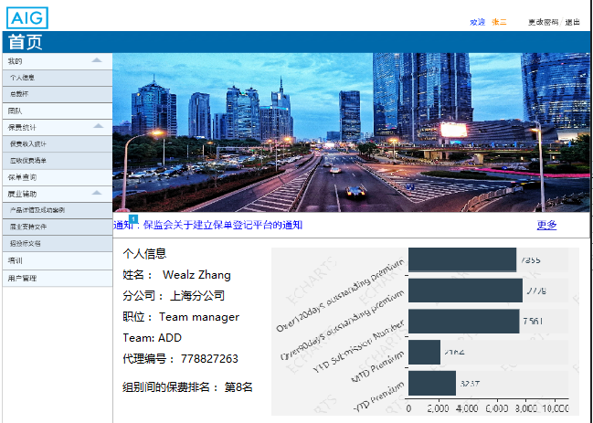

Field Specifications
Field Name | Type | Dropdown List Content | Mandatory | Attribute (Editable/Read Only) | Validation | Remark
姓名 | Text | NA | Yes | Ready Only | Follow Business rule | Name
分公司 | Text | NA | Yes | Ready Only | Follow Business rule | Branch
职位 | Text | NA | Yes | Ready Only | Follow Business rule | Position
Team | Text | NA | Yes | Ready Only | Follow Business rule | Team
代理编号 | Text | NA | Yes | Ready Only | Follow Business rule | Producer Code
排名 | Text | NA | Yes | Ready Only | Follow Business rule | Rank

Mine Information

Sub Function1: My employee information
Sub Function Name | My employee information
Brief Description | This sub function enables the user to view their own employee information.
Actor(s) | Users
Pre-Conditions | The actor have login and open <personal page>.
Flow of Events | Normal Flow:
Flow of Events | - Actor use employee account to login and open <personal page>  - Actor can view but not edit their own information  - Actor can contact admin user offline to change information  - Admin user login with admin account, search for employees who need to modify information.  - When employee information or status is update, the portal will send email to corresponding user and cc to nominated email account  - The flow end
Flow of Events | Alternate Flow / Exceptions:
Flow of Events | Alternative Flow 1: Share the name card  - When the actor has clicked “分享” link in personal page, user will select where to share.  - If user select WeChat Moments or WeChat friends, the portal call AIG WeChat public account interface to generate a image + text template.  - If user select QQ or Weibo, a HTML5 link will generate in page.  - Actor could share name card to social network  - If client click link, they could view information about this employee
Flow of Events | Extensions
Flow of Events | None
Post-Condition | Actor can view or edit information successfully.

Business Rules
- <personal>page will contain employee information and a user list. Employee information will be included:
- Name
- Branch
- Position
- Alternative Position (same as the position on business card)
- Team
- Employee No.
- Contact No.
- Email account
- Agent qualification No.
- Producer code/Sub code
- Assistant’s id
- Status(active/inactive)
When user login with general account, all employee information cannot edit. Only admin user could edit employee’s information at user management module.

- When user click [share] button, a float page will pop up below the <personal>page. After user select share the name card to WeChat Moments or WeChat friends in the float page, the portal will call AIG WeChat public account interface to generate an image + text template. Then share this link to WeChat Moments or WeChat friends.

- When user click [share] button and choose to share to QQ or Weibo, browser will generate a H5 link share to social network.

- When client click HTML5link, will be directed to the <personal> page and details should include：
- Name
- Branch
- Alternative Position
- Team
- Contact No.
- Email account
- Agent qualification No. (display only for DS)

UI

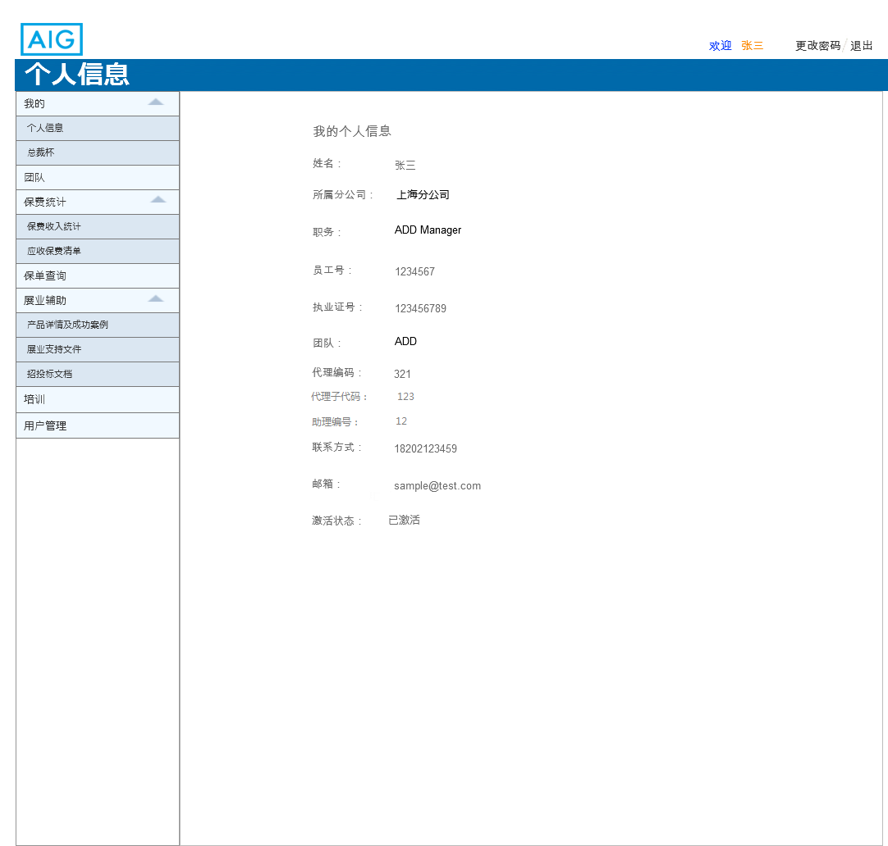
6.3.1_1 personal page

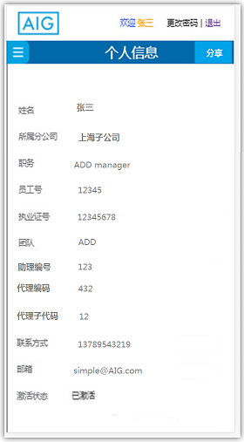
6.3.1_2 share page

Field Specifications
Field Name | Type | Dropdown List Content | Mandatory | Attribute (Editable/Read Only) | Validation | Remark
用户名 | Text | NA | Yes | Editable | 1.非空校验  2.格式校验 | Account ID
姓名 | Text | NA | Yes | Editable | 1.非空校验  2.格式校验 | Name
所属分公司 | Dropdown list | Shanghai/Guangdong/Shenzhen/  Beijing/Jiangsu/Zhejiang | Yes | Editable | 1.非空校验 | Branch
职务 | Dropdown list | means alternative position | Yes | Editable | 1.非空校验 | Position
员工号 | Text | NA | Yes | Editable | 1.非空校验  2.格式校验 | Employee No.
联系方式 | Text | NA | Yes | Editable | 1.非空校验  2.格式校验 | Contact No.
邮箱 | Text | NA | Yes | Editable | 1.非空校验  2.格式校验 | Email account
注册 | Button | NA | NA | Read Only | 页面无错误提示 | Submit
执业证号 | Text | NA | Conditional mandatory | Editable | 1.非空校验  2.格式校验 | Agent qualification No.
团队 | Dropdown list | ADD/DS/CBE(Optional for CDO/Op manager/Branch GM) | Conditional mandatory | Editable | 1.非空校验 | Team
代理编码 | Text | NA | Yes | Editable | 1.非空校验  2.格式校验 | Product code
代理子代码 | Text | NA | Yes | Editable | 1.非空校验  2.格式校验 | Product  Sub Code
助理编码 | Text | NA | Yes | Editable | 1.非空校验  2.格式校验 | Assistant

Sub Function 2: My President Conference campaign
Sub Function Name | My President Conference Campaign
Brief Description | Distribution portal shall be able to show a comparison between the actual business completion status (current year) and president’s cup campaign qualification with graph.
Actor(s) | User
Pre-Conditions | Assistant or admin user has already upload the president conference campaign statistics.
Flow of Events | Normal Flow:
Flow of Events | - After user click this module, the portal will find the user’s position and team first.  - Then the portal will search the employee’s president conference statistics from the newest cut-off date record.  - And user could view his/her gap between actual business completion and the qualification.
Flow of Events | Alternate Flow / Exceptions:
Flow of Events | N/A
Flow of Events | Extensions:
Flow of Events | None
Post-Condition

Business Rules
- When the user opens this < President Conference campaign> page, the portal will use the user’s “branch”, “team” and “employee id” to search his/her statistics from the newest cut-off date record.
  - If the user’s “team” is “DS”, the portal need fetch “GPW Growth Requirement-single” , “GPW Growth Requirement-double”, “Gap-single” , “Gap-double”
  - If the user’s “team” is “ADD”, the portal need fetch “GPW Growth Requirement (excl ITA)-single” , “GPW Growth Requirement(excl ITA)-double”, “Gap-single(excl ITA)” , “Gap-double(excl ITA)”, “GPW Growth Requirement (incl ITA)-single” , “GPW Growth Requirement(incl ITA)-double”, “Gap-single(incl ITA)” , “Gap-double(incl ITA)”,

- After the portal get the data, it need display as GPW VS Gap.
Team | Single or Double | Data Bar
DS | Single | “GPW Growth Requirement-single” VS “Gap-single”
DS | Double | “GPW Growth Requirement-double” VS “Gap-double”
ADD | Single  Single | “GPW Growth Requirement (excl ITA)-single” VS “Gap-single (excl ITA)”
ADD | Single  Single | “GPW Growth Requirement (incl ITA)-single” VS “Gap-single (incl ITA)”
ADD | Double  Double | “GPW Growth Requirement (excl ITA)-double” VS “Gap-double (excl ITA)”
ADD | Double  Double | “GPW Growth Requirement (incl ITA)-double” VS “Gap-double (incl ITA)”,

- For this page, PC & mobile will use the same display. Page will be auto adaptive to the device size.

UI
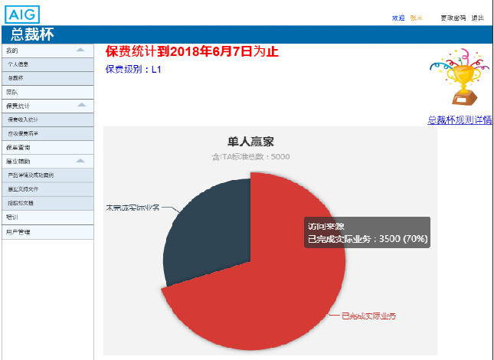

Field Specifications

Team Member’s information

Sub Function 1: View team member’s employee information

Sub Function Name | View team member’s employee information
Brief Description | This sub function enables the user to view team member’s employee information.
Actor(s) | Supervisors and assistants
Pre-Conditions | The actor have login and open <team page>.
Flow of Events | Normal Flow:
Flow of Events | - When actor login and click “团队”in overview page, team page will be display  - After click “查看” link, actor could view team member’s employee information.  - When actor click [premium] bottom at the right of the record, the premium page will display  - When actor click [submission] bottom at the right of the record, the premium page will display  - The flow end
Flow of Events | Alternate Flow / Exceptions:
Flow of Events | Alternative flow 1: If. share team member’s information  - This sub function is invoked when the actor has clicked “分享” link in team page  - After click “分享” link, user will select where to share.  - If user select WeChat Moments or WeChat friends, the portal will call AIG WeChat public account interface to generate an image + text template.  - If user select QQ or Weibo, a HTML5 link will generate in page.  - If client click link, they could view information about this employee  Alternative flow 2: If query team members  - When actor login and click “团队”in overview page, team page will be display  - After actor input some criteria and click [查询], system will select all eligible people from DB  - Then team member’s employee information will display  - The flow end
Flow of Events | Extensions:
Flow of Events | None
Post-Condition | Actor can view team member’s employee information successfully.

Business Rules
- <team>page will contain a query criteria part and a team list part. When user open this page, product list will display. All product records and sort by latest time. Each page should display 5 records. Page details are as below:
- Name
- Branch:
- Position
- Alternative position
- Team
- Employee No.
- Contact No.
- Email account
- Agent qualification No.: Editable when the position is DS\

- Display two buttons on each record to redirect to premium and submission page respectively. And when redirect to premium and submission page, the person will be selected automatically in the search criteria.
- Distribution Portal should allow fuzzy search for all query function. If the search condition is null, display all data. Admin user/supervisor/assistant could query the users by below criteria:
- By Branch
- By user name
- By user ID
- By team
- By position

- When user click [share] button, a float page will pop up below the <team>page.
- After user select share the name card to WeChat Moments or WeChat friends in the float page, the system jump to WeChat and invokes a link template from the WeChat interface. Then share this link to which user selected.
- When client click HTML5link, details should include：
- Name
- Branch
- Alternative Position
- Team
- Contact No.
- Email account
- Agent qualification No. (display only for DS)

UI

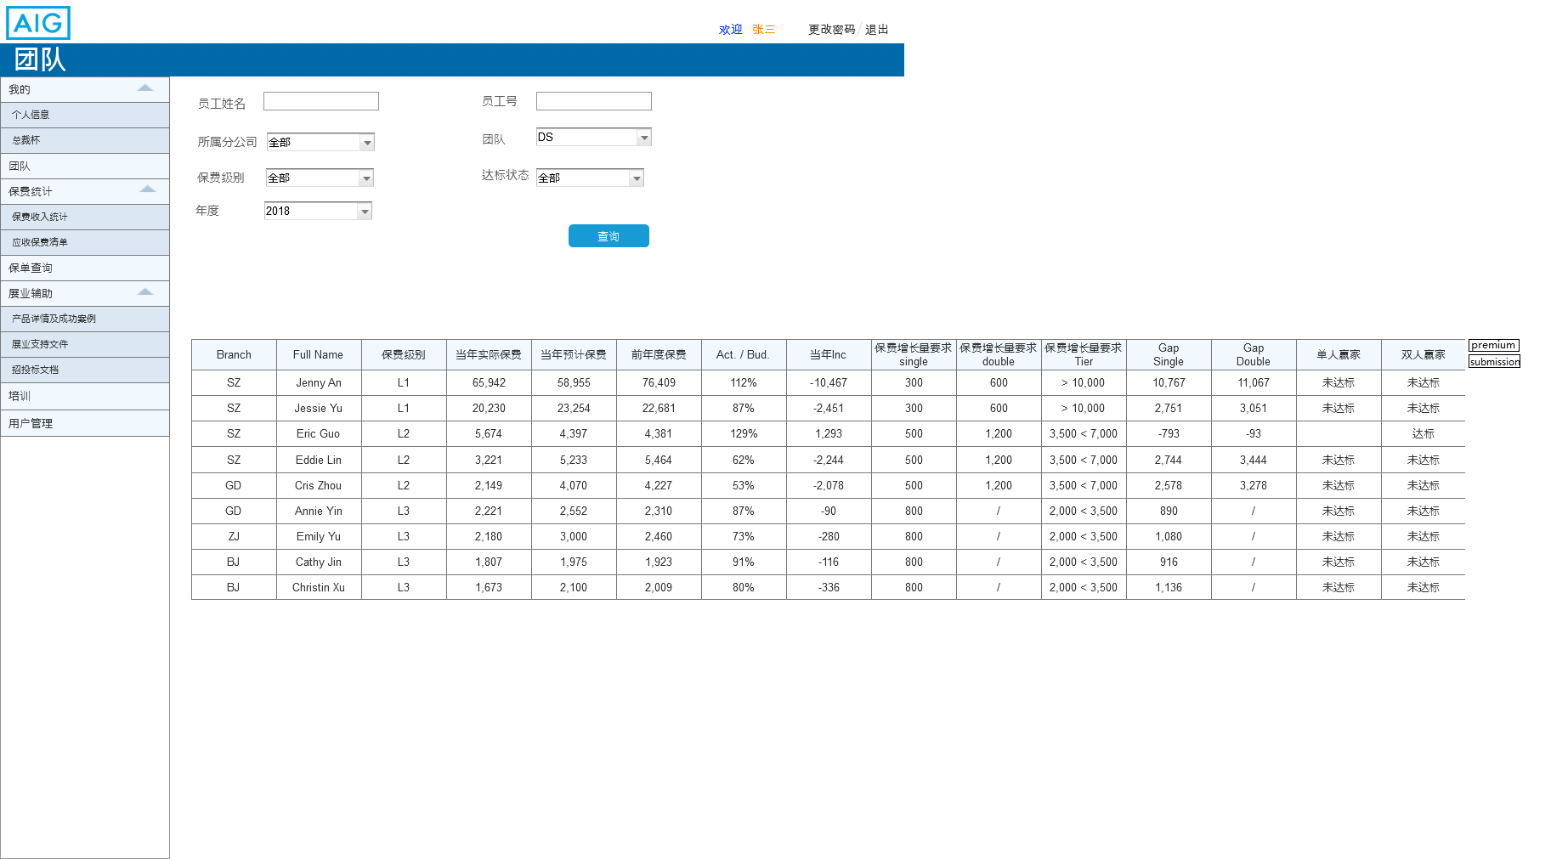
7.3.1.2_1 team page in PC
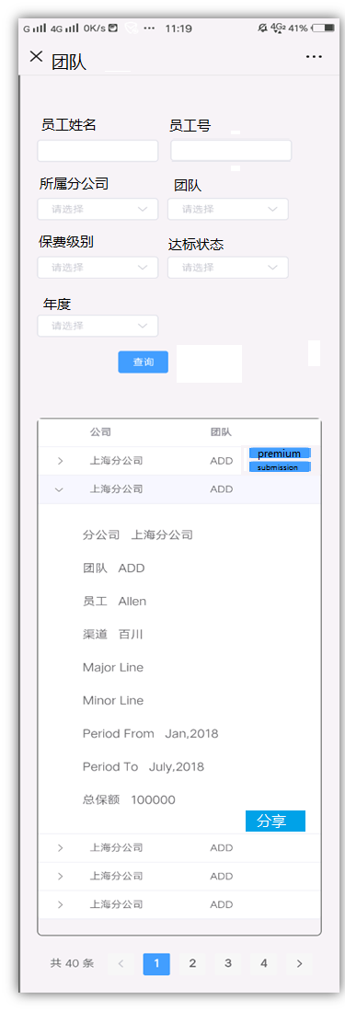
7.3.1.2_2 team page in mobile

Field Specifications
Field Name | Type | Dropdown List Content | Attribute (Editable/Read Only) | Remark
员工号 | Text | NA | Editable | Employee No.
姓名 | Text | NA | Editable | Name
所属分公司 | Dropdown list | Shanghai/Guangdong/Shenzhen/  Beijing/Jiangsu/Zhejiang | Editable | Branch
团队 | Dropdown list | AIG provide | Editable | Team
年度 | Text | AIG provide | Editable | Annual

Sub Function 2: Team member’s President Conference campaign
Sub Function Name | Team member’s President Conference Campaign
Brief Description | Distribution portal shall be able to show a comparison between the actual business completion status (current year) and president’s cup campaign qualification with graph.
Actor(s) | Assistant/ Team manager/ CHO/CDO/OP manager/ Admin
Pre-Conditions | Assistant or admin user has already upload the president conference campaign statistics.
Flow of Events | Normal Flow:
Flow of Events | - After user click this module, the portal will find the user’s position and team first.  - If the user’s position is “assistant/ Team manager/ CHO/CDO/OP manager/ Admin”, the portal will display a query page first.  - User should search the data of one employee, and click the [detail] button to view the gap bar of the employee.
Flow of Events | Alternate Flow / Exceptions:
Flow of Events | N/A
Flow of Events | Extensions:
Flow of Events | None
Post-Condition

Business Rules
- When assistant/ Team manager/ CHO/CDO/OP manager/ Admin access to this module, the portal will display a query page first. Some criteria will be default and disable base one the user’s position. Details are as below:
Criteria | Position
Criteria | Assistant | Team Manager | GM | CHO/CDO/OP Manager/ Admin
Branch | Default as the user’s branch and cannot edit. |  |  | Free to choose
Person | Free to input
Employee ID | Free to input
Team | Default as the user’s team and cannot edit. |  | Free to choose

- Before user click [Search] button, the portal will search out all data which is in the user’s pool. Each user will have different pool size.
  - For Assistant: Only the employee whose “assistant” (this factor is in the employee’s user account) is the login user, his/her data will in the assistant’s pool.
  - For Team Manager: Only the employee whose “Team” (this factor is in the employee’s user account) is as same as the login user’s “team”, his/her data will in the team manager’s pool.
  - For GM: Only the employee whose “Branch” (this factor is in the employee’s user account) is as same as the login user’s “branch”, his/her data will in the GM’s pool.
  - For CHO/CDO/OP Manager/ Admin: every employee’s data will in CHO/CDO/OP Manager/ Admin’s pool.

- After user click [Search] button, the portal will fuzzy query by criteria in the user’s pool and display the result. The mapping method is as below:
Criteria | Mapping to [president conference campaign table]
Branch | Mapping to the “branch” field
Person | Mapping to the “name” field
Employee ID | Mapping to the “Employee id” field
Team | Mapping to the “team” field

- If user want to clear all criteria, he/ she could click [clear] button.

- The President conference campaign list should be paging by 10 records and sort by employee id from the smallest to the biggest. For this page, PC & mobile will use the same display. Page will be auto adaptive to the device size.
  - The result list will display as a small table only contain the main information of the employee and user could click [detail] button at the end of each record to view as the graph version.
    - Result list table will display information including:
      - Branch
      - Name: the employee’s name
      - Employee id
      - Team
    - After click [Detail] button, the portal will pop up a new page to display the employee’s president conference campaign by gap bar. The page display and format should follow “my president conference campaign”

UI
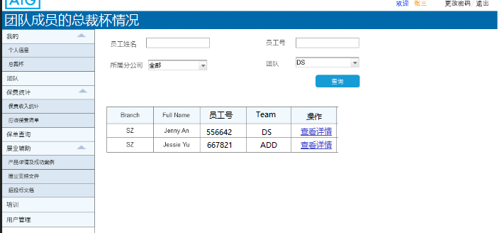

After click [detail] button will open below page:
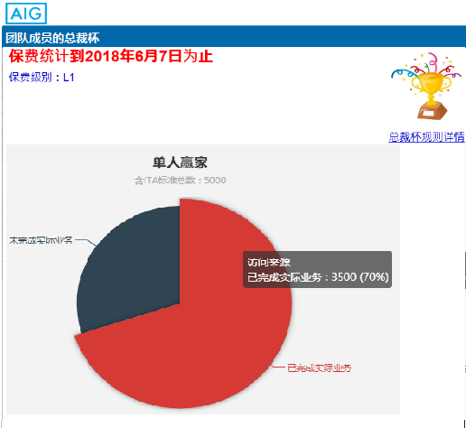

Field Specifications
N/A

Submission statistics

Sub Function 1: Submission statistics
Sub Function Name | Submission statistics
Brief Description | User could view his or her own submission statistics here. Supervisor and assistant could view his /her team member’s submission statistics here.
Actor(s) | User
Pre-Conditions | Admin or assistant has already update the submission statistics into the distribution portal.
Flow of Events | Normal Flow:
Flow of Events | - If the user’s position is ADD/ CBE/ DS, he/she could search information by “major line”, “Minor line”, “Channel” or period”.  - After click [search] button, the portal will search submission statistics from his/her own premium income report.  - The flow end
Flow of Events | Alternate Flow / Exceptions:
Flow of Events | Alternative flow 1: Team manager or assistant view this module.  - If the user’s position is Supervisor or assistant, he/she could search information by “major line”, “Minor line”, “Channel”, “period”, “Branch”, “person”, “team”.  - After click [search] button, the Portal will search submission statistics from his/her team and team member’s submission statistics report.  - The flow end  Alternative flow 2: CHO/CDO/OP Manager /Admin user to view this module  - If the user’s position is the Admin, he/she could input the query criteria as many as they want and then click [search]  - Then the portal will search submission statistics from all staff pool.  - The flow end
Flow of Events | Extensions:
Flow of Events | None
Post-Condition

Business Rules
- For different user, when user access to this module, the portal will default and disable some query criteria. Details are as below:
Criteria | Position
Criteria | Staff(ADD/CBE/DS) | Assistant | Team Manager | GM | CHO/CDO/OP Manager/ Admin
Branch | Default as the user’s branch and cannot edit. |  |  |  | Free to choose
Person | Default as the user’s name and cannot edit. | Free to input
Team | Default as the user’s team and cannot edit. |  |  | Free to choose
Channel | Only when the criteria “Team” is “ADD” or “CBE” this field is enable to select. |  |  | Free to choose
Period | Free to input or choose
Major line
Minor line

- The submission statistics are uploaded by Admin through < submission statistics uploading> module. Any details please refer to 7.9.4- submission statistics uploading.

- Before user click [Search] button, the portal will search out all data which is in the user’s pool. Each user will have different pool size.
  - For Staff: he/she could only view his/her own data. Which means only the employee whose “branch’ & “employee no.” & “team” (this factor is in the employee’s user account) is exactly same as the login user, the data will in the staff pool.
  - For Assistant: Only the employee whose “assistant” (this factor is in the employee’s user account) is the login user, his/her data will in the assistant’s pool.
  - For Team Manager: Only the employee whose “Team” (this factor is in the employee’s user account) is as same as the login user’s “team”, his/her data will in the team manager’s pool.
  - For GM: Only the employee whose “Branch” (this factor is in the employee’s user account) is as same as the login user’s “branch”, his/her data will in the GM’s pool.
  - For CHO/CDO/OP Manager/ Admin: every employee’s data will in CHO/CDO/OP Manager/ Admin’s pool.

- After user click [Search] button, the portal will fuzzy query by criteria in the user’s pool and display the result. The mapping method is as below:
Criteria | Mapping to [submission statistics table]
Branch | Mapping to the “branch” field
Person | Mapping to the “Creator” field
Team | Mapping to the “team” field
Channel | Mapping to the “Channel” field
Period | Year mapping to the “Financial year” field, month mapping to “ month” field
Major line | Mapping to the “Major Line” field
Minor line | Mapping to the “Minor line” field

- If user want to clear all criteria, he/ she could click [clear] button.

- User could user the [Download] function to download the search result as a csv format. But the [Download] function is only enable for PC version.

- There will have a “submission no. summary” at the middle of query part and result list. It will display at the most right. “Submission no. summary” equal to the total number of result records. For example, if the result list has 30 records, submission no. summary will be 30.

- The result list should be paging by 10 records and sort by “received time” from the nearest day to the farthest day. The list will have different styling for PC and Mobile:
  - On PC: the result list will display as a detail table, including below fields:
      - Branch
      - WIP No
      - Policy No
      - Major line
      - Minor line
      - Request type
      - Sub no.
      - Creator
      - Print user
      - Insured name
      - Priority
      - Owner
      - Received time
      - Finished time
      - Producer Code
      - Producer name
      - Issue SLA
      - Binding Date
      - Current eff Dt.
      - Financial Year
      - Month

  - On mobile: the result list will display as folded table to display some main information. If user want to view the details, they could click the record to unfold it.
    - Main information including:
      - WIP No.
      - Policy No.
      - Major line
      - Minor line
      - Financial year
      - Month
    - Detail information including:
      - Branch
      - Request type
      - Sub no.
      - Creator
      - Print user
      - Insured name
      - Priority
      - Owner
      - Received time
      - Finished time
      - Producer Code
      - Producer name
      - Issue SLA
      - Binding Date
      - Current eff Dt.

UI

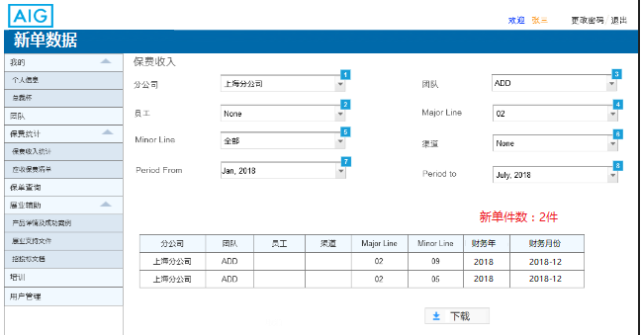

Field Specifications
Field Name | Type | Dropdown List Content | Attribute (Editable/Read Only) | Remark
分公司 | Dropdown list | Shanghai/Guangdong/Shenzhen/  Beijing/Jiangsu/Zhejiang | Editable | Branch
团队 | Dropdown list | ADD/DS/CBE | Editable | Team
员工 | TEXT |  | Editable | Name
Major Line | Dropdown list | AIG provide | Editable | Major Line
Minor Line | Dropdown list | AIG provide | Editable | Minor Line
渠道 | Dropdown list |  |  | Channel
Period | Text |  | Editable | Period

Premium Statistics

Sub Function 1: Premium Income report

Sub Function Name | Premium Income Report
Brief Description | User could view his or her own premium income report here. Supervisor and assistant could view his /her team member’s premium income list here.
Actor(s) | User
Pre-Conditions | User login Distribution Portal
Flow of Events | Normal Flow: ADD/CBE/DS staff
Flow of Events | - If the user’s position is ADD/ CBE/ DS, he/she could search information by “major line”, “Minor line”, “Channel” or period”.  - After click [search] button, the portal will search premium income statistics from his/her own premium income report.  - The flow end
Flow of Events | Alternate Flow / Exceptions:
Flow of Events | Alternative flow 1: Team manager or assistant view this module.  - If the user’s position is Supervisor or assistant, he/she could search information by “major line”, “Minor line”, “Channel”, “period”, “Branch”, “person”, “team”.  - After click [search] button, the Portal will search premium income statistics from his/her team and team member’s premium income report.  - The flow end  Alternative flow 2: CHO/CDO/OP Manager /Admin user to view this module  - If the user’s position is the Admin, he/she could input any query criteria as they want and then click [search]  - Then the portal will search premium income statistics from all staff pool.  - The flow end
Flow of Events | Extensions:
Flow of Events | None
Post-Condition

Business Rules
- For different user, when user access to this module, the portal will default and disable some query criteria. Details are as below:

Criteria | Position
Criteria | Staff(ADD/CBE/DS) | Assistant | Team Manager | GM | CHO/CDO/OP Manager/ Admin
Branch | Default as the user’s branch and cannot edit. |  |  |  | Free to choose
Person | Default as the user’s name and cannot edit. | Free to input
Team | Default as the user’s team and cannot edit. |  |  | Free to choose
Channel | Only when the criteria “Team” is “ADD” or “CBE” this field is enable to select. |  |  | Free to choose
Period | Free to input or choose
Major line
Minor line

- The portal will build a SSIS to query premium income report from GoalD. AIG will provide the SQL. The premium statistics will have 1day gap between distribution portal and GoalD. If any error occurs when query data, the portal will trigger an email to Admin and record the error log. Email will like below:
  - Trigger point: If any error occurs when query data then it will trigger this email.
  - From:
  - To: the nominated user’s email address
  - CC:
  - Subject: [Distribution portal] ETL failed to query data from Goal D
  - Content:
[ date / time] ETL failed to query data from Goal D, please help solve this error.

- Before user click [Search] button, the portal will search out all data which is in the user’s pool. Each user will have different pool size.
  - For Staff: he/she could only view his/her own data. Which means only the employee whose “branch’ & “employee no.” & “team” (this factor is in the employee’s user account) is exactly same as the login user, the data will in the staff pool.
  - For Assistant: Only the employee whose “assistant” (this factor is in the employee’s user account) is the login user, his/her data will in the assistant’s pool.
  - For Team Manager: Only the employee whose “Team” (this factor is in the employee’s user account) is as same as the login user’s “team”, his/her data will in the team manager’s pool.
  - For GM: Only the employee whose “Branch” (this factor is in the employee’s user account) is as same as the login user’s “branch”, his/her data will in the GM’s pool.
  - For CHO/CDO/OP Manager/ Admin: every employee’s data will in CHO/CDO/OP Manager/ Admin’s pool.

- After user click [Search] button, the portal will fuzzy query by criteria in the user’s pool and display the result. The mapping method is as below:
Criteria | Mapping to [Premium income table]
Branch | Mapping to the “branch” field
Person | Mapping to the “Creator” field
Team | Mapping to the “team” field
Channel | Mapping to the “Channel” field
Period | Mapping to “ month” field
Major line | Mapping to the “Major Line” field
Minor line | Mapping to the “Minor line” field

- If user want to clear all criteria, he/ she could click [clear] button.

- User could user the [Download] function to download the search result as a csv format. But the [Download] function is only enable for PC version.

- There will have a “premium income summary” at the middle of query part and result list. It will display at the most right. “premium income summary” equal to the totaling result records’ premiums (because all premium is in CYN, the portal just need totaling the premium.)

- The premium income list should be paging by 10 records and sort by policy effective date from the nearest day to the furthest day. The list will have different styling for PC and Mobile:
  - On PC: the result list will display as a detail table, including below fields:
    - Branch
    - Team
    - Employee’s name
    - Employee’s id
    - Channel
    - Major line
    - Minor line
    - Period from
    - Period to
    - Premium (CNY)

  - On mobile: the result list will display as folded table to display some main information. If user want to view the details, they could click the record to unfold it.
    - Main information including:
      - Employee’s name
      - Employee’s id
      - Premium (CNY)
    - Detail information including:
      - Branch
      - Team
      - Channel
      - Major line
      - Minor line
      - Period from
      - Period to

UI
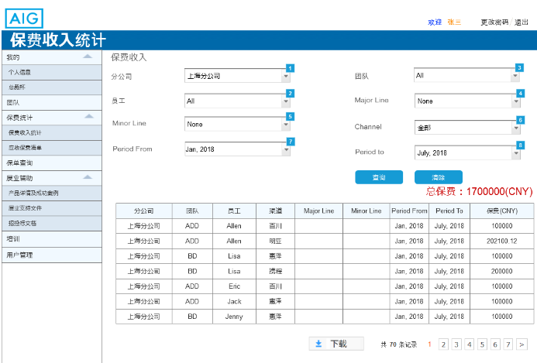

Field Specifications
Field Name | Type | Dropdown List Content | Attribute (Editable/Read Only) | Remark
分公司 | Dropdown list | Shanghai/Guangdong/Shenzhen/  Beijing/Jiangsu/Zhejiang | Editable | Branch
团队 | Dropdown list | ADD/DS/CBE | Editable | Team
员工 | TEXT |  | Editable | Name
Major Line | Dropdown list | AIG provide | Editable | Major Line
Minor Line | Dropdown list | AIG provide | Editable | Minor Line
渠道 | Dropdown list |  |  | Channel
Period | Text |  | Editable | Period

Sub Function 2: Premium receivable list

Sub Function Name | Premium Receivable list
Brief Description | User could view his or her own Premium Receivable list here. Supervisor and assistant could view his /her team member’s Premium Receivable list here.
Actor(s) | User
Pre-Conditions | User login Distribution Portal and Admin has already update premium receivable list.
Flow of Events | Normal Flow:
Flow of Events | - If the user’s position is ADD/ CBE/ DS, he/she could search information by “overdue period”.  - After click [search] button, the portal will search premium income statistics from his/her own premium income report.  - The flow end
Flow of Events | Alternate Flow / Exceptions:
Flow of Events | Alternative flow 1: Team manager or assistant view this module.  - If the user’s position is Supervisor or assistant, he/she could search information by “person”, “overdue period”.  - After click [search] button, the Portal will search premium income statistics from his/her team and team member’s premium income report.  - The flow end  Alternative flow 2: CHO/CDO/OP Manager /Admin user to view this module  - If the user’s position is the Admin, he/she could input any query criteria as they want and then click [search]  - Then the portal will search premium income statistics from all staff pool.  - The flow end
Flow of Events | Extensions:
Flow of Events | None
Post-Condition

Business Rules
- For different user, when user access to this module, the portal will default and disable some query criteria. Details are as below:

Criteria | Position
Criteria | Staff(ADD/CBE/DS) | Assistant | Branch Manager | GM | CHO/CDO/OP Manager/ Admin
Branch | Default as the user’s branch and cannot edit. |  |  |  | Free to choose
Person | Default as the user’s name and cannot edit. | Free to input
Team | Default as the user’s team and cannot edit. |  |  | Free to choose
Channel | Only when the criteria “Team” is “ADD” or “CBE” this field is enable to select. |  |  | Free to choose
Overdue period | Free to input or choose

- The premium receivable statistics are uploaded by Admin through <Premium receivable list uploading> module. Any details please refer to 7.9.5-Premium receivable list uploading.

- Before user click [Search] button, the portal will search out all data which is in the user’s pool. Each user will have different pool size.
  - For Staff: he/she could only view his/her own data. Which means only the employee whose “branch’ & “employee no.” & “team” (this factor is in the employee’s user account) is exactly same as the login user, the data will in the staff pool.
  - For Assistant: Only the employee whose “assistant” (this factor is in the employee’s user account) is the login user, his/her data will in the assistant’s pool.
  - For Team Manager: Only the employee whose “Team” (this factor is in the employee’s user account) is as same as the login user’s “team”, his/her data will in the team manager’s pool.
  - For GM: Only the employee whose “Branch” (this factor is in the employee’s user account) is as same as the login user’s “branch”, his/her data will in the GM’s pool.
  - For CHO/CDO/OP Manager/ Admin: every employee’s data will in CHO/CDO/OP Manager/ Admin’s pool.

- After user click [Search] button, the portal will fuzzy query by criteria in the user’s pool and display the result. The mapping method is as below:
Criteria | Mapping to [submission statistics table]
Branch | Mapping to the “branch” field
Person | Mapping to the “Creator” field
Team | Mapping to the “team” field
Channel | Mapping to the “Channel” field
Overdue Period | Year mapping to the “overdue period” field

- If user want to clear all criteria, he/ she could click [clear] button.

- User could user the [Download] function to download the search result as a csv format. But the [Download] function is only enable for PC version.

- There will have a “Premium receivable summary” at the middle of query part and result list. It will display at the most right. “Premium receivable summary” equal to the totaling result records’ “booked premiums” (all premium need use the exchange rate to trans to CNY).

- The premium receivable list should be paging by 10 records and sort by “overdue period” from “under 30 days” to “under 90 days” and sort by booking date from the nearest day to the furthest day. The list will have different styling for PC and Mobile:
- On PC: the result list will display as a detail table, including below fields:
  - Sales Office Cd
  - Overdue period
  - Effective Date
  - Booking Date
  - Producer Type
  - Producer main Cd
  - Producer Sub Cd
  - Producer Name
  - Producer Group
  - Producer Group name
  - Assured Name
  - Master Policy No.
  - Policy No.
  - Debits No.
  - Cert No.
  - Rent. Cert. No
  - Trans. No.
  - Install. No.
  - Mgr. Cd
  - Lob
  - Dept. Cd
  - Dept. Name
  - Prem. Curr.
  - Booked premium
  - Commission rate
  - Orig amt
  - Net premium
  - RMBEQ
  - Invoice No.
  - Producing Office
  - Request No.
  - End. Code
  - End. Reason
  - client_name
  - phone
  - email
  - address
  - Remarks
  - R/I slip No.

- On mobile: the result list will display as folded table to display some main information. If user want to view the details, they could click the record to unfold it.
- Main information including:

- Detail information including:

UI
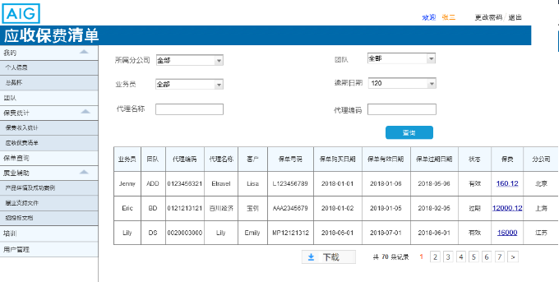

Field Specifications
Field Name | Type | Dropdown List Content | Attribute (Editable/Read Only) | Remark
分公司 | Dropdown list | Shanghai/Guangdong/Shenzhen/  Beijing/Jiangsu/Zhejiang | Editable | Branch
团队 | Dropdown list | ADD/DS/CBE | Editable | Team
员工 | TEXT |  | Editable | Name
代理编号 | TEXT |  | Editable | Producer code

Policy Inquiry

Sub Function 1: Policy Inquiry

Sub Function Name | Policy Inquiry
Brief Description | User could view his or her own client or channel’s policy details. Supervisor and assistant could view his /her team member’s policy details here.
Actor(s) | User
Pre-Conditions | User login Distribution Portal
Flow of Events | Normal Flow:
Flow of Events | - User could search information by criteria.  - After click [search] button, the portal will search policy details from DB.  - The flow end
Flow of Events | Alternate Flow / Exceptions:
Flow of Events | Alternative flow 1: If there is no search result.  - User could search information by criteria.  - After click [search] button, the portal will search policy details from DB.  If there has no result, the portal will display error message like “此保单可能是Bulk booking的保单，无法在Distribution Portal, 请到出单系统查询或检查查询条件是否正确”  - The flow end
Flow of Events | Extensions:
Flow of Events | None
Post-Condition

Business Rules
- For different user, when user access to this module, the portal will default and disable some query criteria. Details are as below:

Criteria | Position
Criteria | Staff(ADD/CBE/DS) | Assistant | Branch Manager | GM | CHO/CDO/OP Manager/ Admin
Branch | Default as the user’s branch and cannot edit. |  |  |  | Free to choose
Person | Default as the user’s name and cannot edit. | Free to input
Team | Default as the user’s team and cannot edit. |  |  | Free to choose
Channel | Only when the criteria “Team” is “ADD” or “CBE” this field is enable to select. |  |  | Free to choose
Period | Free to input or choose
Major line
Minor line
Policy No.

- The portal will build a SSIS to query policy details from GoalD. AIG will provide the SQL. The policy details will have 1day gap between distribution portal and GoalD. If any error occurs when query data, the portal will trigger an email to Admin and record the error log.

- Before user click [Search] button, the portal will search out all data which is in the user’s pool. Each user will have different pool size.
  - For Staff: he/she could only view his/her own data. Which means only the employee whose “branch’ & “employee no.” & “team” (this factor is in the employee’s user account) is exactly same as the login user, the data will in the staff pool.
  - For Assistant: Only the employee whose “assistant” (this factor is in the employee’s user account) is the login user, his/her data will in the assistant’s pool.
  - For Team Manager: Only the employee whose “Team” (this factor is in the employee’s user account) is as same as the login user’s “team”, his/her data will in the team manager’s pool.
  - For GM: Only the employee whose “Branch” (this factor is in the employee’s user account) is as same as the login user’s “branch”, his/her data will in the GM’s pool.
  - For CHO/CDO/OP Manager/ Admin: every employee’s data will in CHO/CDO/OP Manager/ Admin’s pool.

- After user click [Search] button, the portal will fuzzy query by criteria in the user’s pool and display the result. The mapping method is as below:
Criteria | Mapping to [Policy detail table]
Branch | Mapping to the “branch” field
Person | Mapping to the “Creator” field
Team | Mapping to the “team” field
Channel | Mapping to the “Channel” field
Period | Mapping to “ month” field
Major line | Mapping to the “Major Line” field
Minor line | Mapping to the “Minor line” field
Policy No. | Mapping to the “Policy No.” field

- If user want to clear all criteria, he/ she could click [clear] button.

- User could user the [Download] function to download the search result as a csv format. But the [Download] function is only enable for PC version.

- There will have a “Policy summary” at the middle of query part and result list. It will display at the most right. “Policy summary” equal to the totaling number of result records.

- The Policy list should be paging by 10 records and sort by policy effective date from the nearest day to the furthest day. The list will have different styling for PC and Mobile:
- On PC: the result list will display as a detail table, including below fields:
    - Branch
    - Policy No.
    - Effective date
    - Expire date
    - Submission date (录单日期)
    - Commission
    - Premium
    - Currency

- On mobile: the result list will display as folded table to display some main information. If user want to view the details, they could click the record to unfold it.
- Main information including:
      - Policy No.
      - Premium
      - Currency
- Detail information including:
- Branch
- Effective date
- Expire date
- Submission date (录单日期)
- Commission

UI
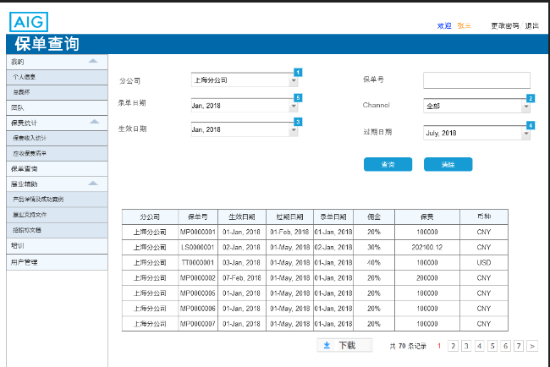

Field Specifications
Field Name | Type | Dropdown List Content | Attribute (Editable/Read Only) | Remark
分公司 | Dropdown list | Shanghai/Guangdong/Shenzhen/  Beijing/Jiangsu/Zhejiang | Editable | Branch
团队 | Dropdown list | ADD/DS/CBE | Editable | Team
员工 | TEXT |  | Editable | Name
保单号 | TEXT |  | Editable | Policy No.
渠道 | Dropdown list |  | Editable | Channel
Period | Text |  | Editable | Period

Sales Support

Sub Function1: Product information
Sub Function Name | Product information inquiry & policy details
Brief Description | This sub function enables the user to view, inquiry share and download product information& policy details.
Actor(s) | user
Pre-Conditions | Actor access to product information page.
Flow of Events | Normal Flow:
Flow of Events | - When actor access to product page, they could view product information  - After actor click [产品详情] button， policy details will display  - After actor click “产品详情下载” link, product details shall be downloaded as PDF file  - After actor click “保单凭证下载” link, policy certificate shall be downloaded as PDF file  - When actor input some tags and click [查询] button, the portal will select all eligible products and display  - The flow end
Flow of Events | Alternate Flow / Exceptions:
Flow of Events | Alternate flow1：Success stories  - When actor click “成功案例”, success stories page will display  - After actor click [详情], success stories will display.  - After actor click [下载成功案例], success stories shell be downloaded as PDF file  - When actor input some tags and click [查询] button, the portal will select all eligible success stories and display  - The flow end  Alternate flow2：If share product details  - This sub function is invoked when the actor has clicked “分享” link in product page  - After click “分享” link, user will select where to share.  - If user select WeChat Moments or WeChat friends, call AIG WeChat public account interface to generate a image + text template.  - If user select QQ or Weibo, a HTML5 link be shared by browser.  - Actor could share product details to social network  - If client click link, they could view detail about this product.
Flow of Events | Extensions:
Flow of Events | None
Post-Condition

Business Rules
- <product>page will contain a query criteria part and a product list part. When user open this page, product list will display. All product records and sort by updating date & time from the latest to the farthest. Each page should display 5 records. The page displays total number of records and pagination. Page details are as below:
  - Query Criteria including:
- By category
- By LOB
- By industry
- By product code
- By product name
- By Risk
  - Product list include product info and actions.
    - Product info including: product name/ product image/product outline
    - Actions:
      - [产品详情] action is enable for all records. After user click this action, <产品详情 > page will pop up and display the product details.
      - [产品详情下载] action is enable for all records. After user click this action, local folders will be opened so that users can choose the download path.
      - [保单凭证下载] action is enable for all records. After user click this action, local folders will be opened so that users can choose the download path.

- <success story>page will contain a query criteria part and a success story list part. When user open this page, success story list will display. All story records and sort by latest uploading time. Each page should display 5 records. User could enquiry the success stories by below criteria:
- By Lob
- By industry
- By risk

- If the search condition is null, display all data.
- when user click [download] button local folders will be opened so that users can choose the download path. When download successfully, the portal will display a success message “下载成功”.

- When user click [share] button in WeChat browser, a float page will pop up below the <product>page. After user select share the name card to WeChat Moments or WeChat friends in the float page, the portal will call AIG WeChat public account interface to generate an image + text template. Then share this link to WeChat Moments or WeChat friends.

- When user click [share] button and choose to share to QQ or Weibo, browser will generate a H5 link share to social network.

- When client click HTML5link, will be directed to the <product> page and details should include：
- Product name
- Product code
- Image
- Product description

UI
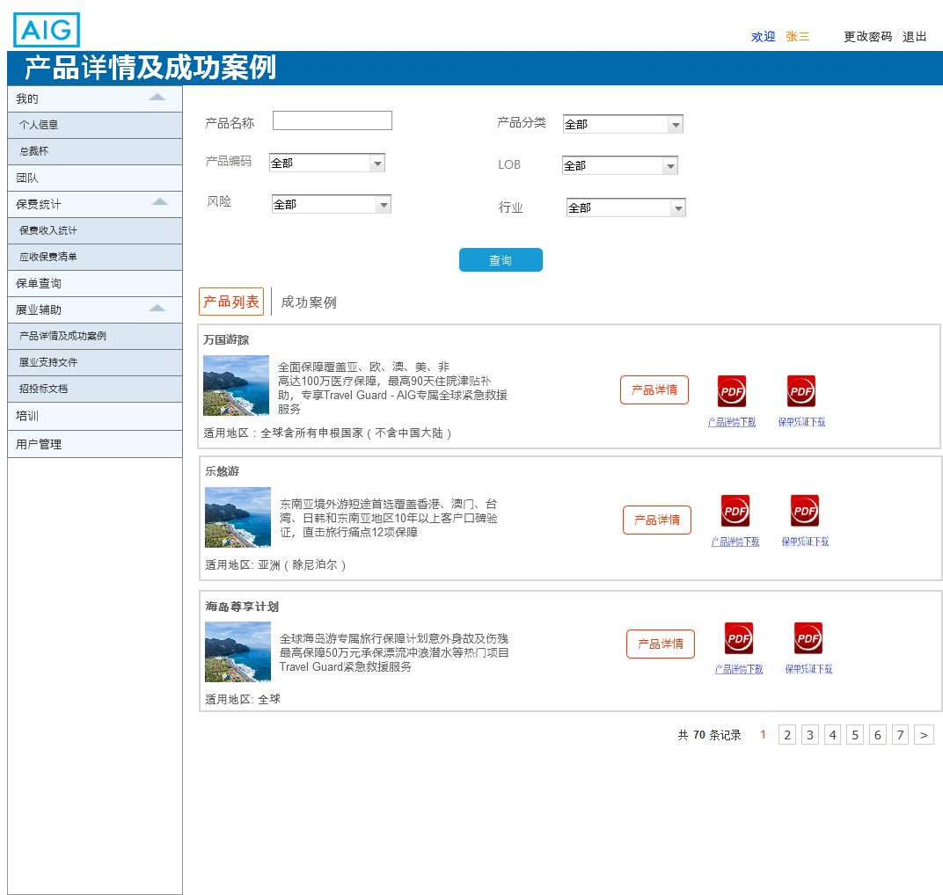
7.4.2.2_1 product page
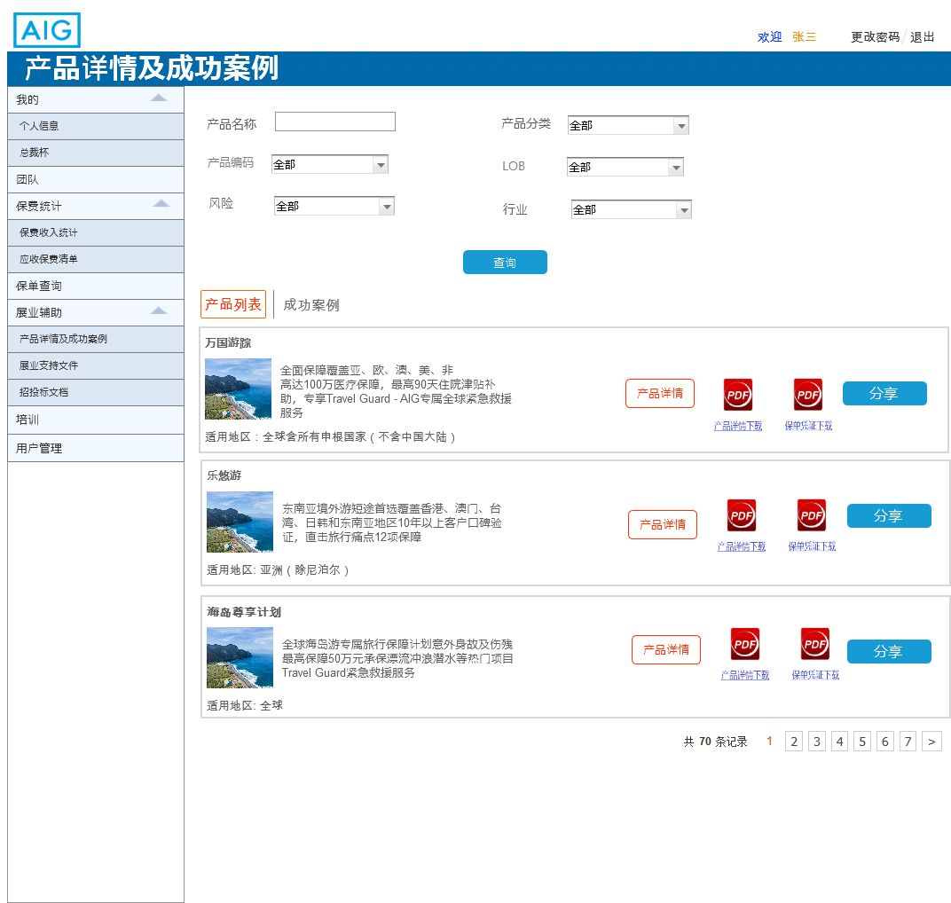
7.4.2.2_3 product share page

Field Specifications
Field Name | Type | Dropdown List Content | Attribute (Editable/Read Only) | Remark
产品名称 | Text | NA | Editable | Product name
产品分类 | Dropdown list | AIG provide | Editable | Product category
产品编码 | Dropdown list | AIG provide | Editable | Product code
成功故事名称 | Text | NA | Editable | Story name
LOB | Dropdown list | AIG provide | Editable | Lob
行业 | Dropdown list | AIG provide | Editable | Industry
风险 | Dropdown list | AIG provide | Editable | Risk

Sub Function2: Sales support practices documents
Sub Function Name | Sales support practices documents
Brief Description | This sub function enables the user to use functions on the page.
Actor(s) | user
Pre-Conditions | Actor access to sale practices page.
Flow of Events | Normal Flow:
Flow of Events | - After actor open sale practices page, four part will display: company qualification material, company introduction material, promotion video and add to favorite  - After click material name link belong to company introduction material part, material details will be displayed in HTML5.  - After click [download] belong to company introduction material part, the file will be downloaded as PDF.  - After click material name link belong to company qualification material, material details will be displayed in PDF.  - After click [download] belong to company qualification material, material details will be downloaded in PDF.  - After click video link belong to promotion video, user could view the promotion video.  - After user perform add some page to favorite, he/she could view the favorite list here.  - User could click link in favorite list to direct to the page.
Flow of Events | Alternate Flow / Exceptions:
Flow of Events | Alternative flow 2: If. share company introduction material  - This sub function is invoked when the actor has clicked [分享] in mobile platform.  - After click [分享] link, user will select where to share.  - if user select WeChat Moments or WeChat friends, the portal will call AIG WeChat public account interface to generate a image + text template.  - If user select QQ or Weibo, a HTML5 link be shared by browser.  - Actor could share company introduction material to social network  - If client click link, they could view company introduction material  Alternative flow 3: If. share promotion video  - This sub function is invoked when the actor has clicked [分享] in mobile platform.  - After click [分享] link, user will select where to share.  - If user select WeChat Moments or WeChat friends, the portal will call AIG WeChat public account interface to generate an image + text template.  - If user select QQ or Weibo, a HTML5 link be shared by browser.  - Actor could share promotion video to social network  - If client click link, they could view video
Flow of Events | Extensions:
Flow of Events | None
Post-Condition | Actor use functions on the page successfully.

Business Rules
 | company introduction material | company qualification material | promotion video
view | In HTML5 | PDF version | Video format
download | PDF version | PDF version | Not download  (Promotion video need set in internal network to avoid being opened at external)

- < sale practice >page will contain four part: Company qualification material, Company introduction material, Promotion video and add to favorite. Except for Company introduction material, each part displays up to 3 links, showing the total number of links below each part. All records are sorted according to the latest upload time.

- User could add website link to favorite in Distribution Portal, then user could easily find the favorite website through login the Distribution Portal. User could only access his/her own favorite folder. If user click [删除]in add to favorite part, the page link will be delete.

UI
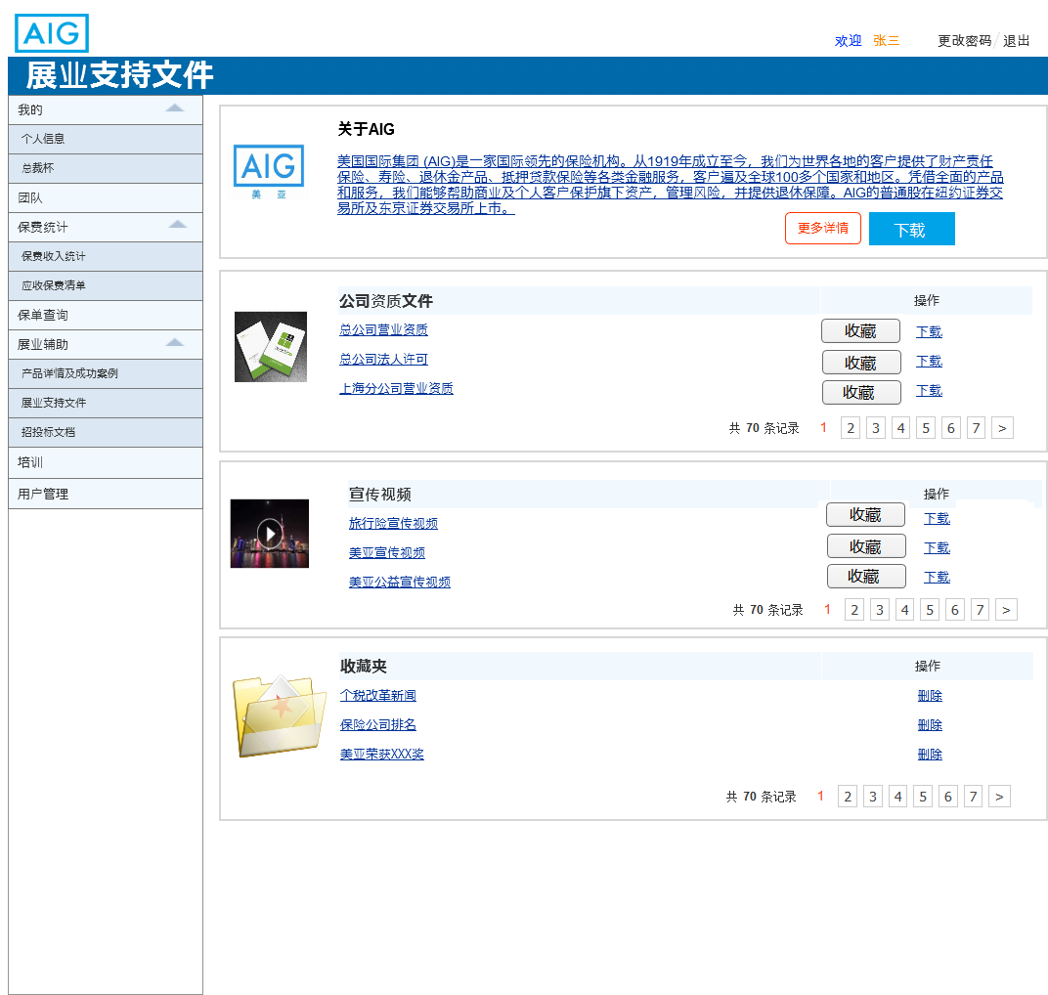
7.5.2.2_1 sales practice PC page
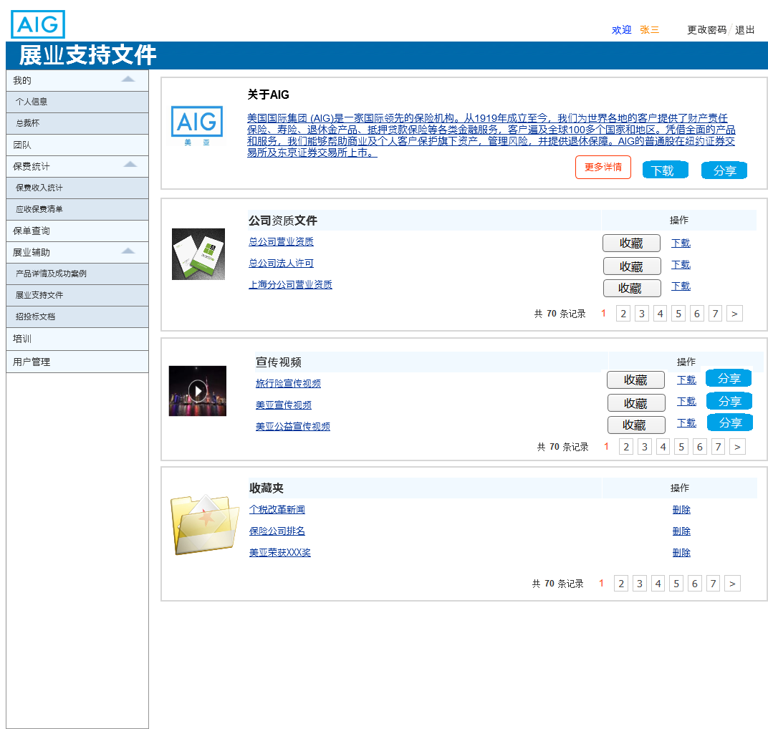
7.5.2.2_1 sales practice MOBLIE page

Field Specifications
NA

Sub Function3: Bidding documents
Sub Function Name | Bidding documents
Brief Description | This sub function enables the user to inquiry or upload bidding documents.
Actor(s) | user
Pre-Conditions | Actor access to bidding documents page.
Flow of Events | Normal Flow:
Flow of Events | - After actor click “招投标文档” in menu, the bidding documents page will display.  - Actor should input inquiry criteria before click [查询]button.  - After actor click[查询]button, the portal will display all consistent results.  - When actor click[详情]button, the portal will display bidding document details.  - When actor click[上传]button, an upload page will display.  - After completing the information, the portal will check whether the information is correct or duplication.  - If check pass, information will be saved.
Flow of Events | Alternate Flow / Exceptions:
Flow of Events | NA
Flow of Events | Extensions:
Flow of Events | None
Post-Condition | Actor use functions on the page successfully.

Business Rules
- < bidding documents >page will contain a query criteria part and a bidding documents list. When user open this page, bidding documents list will display. All user records and sort by latest time. Each page should display 5 records. Page details are as below:
  - Query Criteria including:
    - Industry
    - Product code
    - Product name
    - Risk
  - User list include user info and actions.
    - Bidding documents info including: product name/product overview/ target areas
    - Actions:
      - [查询] action is enable for all records. After user click this action, the portal matches the results according to the input criteria.
      - [上传] action is enable for all records. After user click this action, < upload> page will pop up.
      - [详情] action is enable for all records. After user click this action, the portal will display details of bidding documents.

- If input blank before click[查询], the portal will display all results. If no consistent result, the portal will display an error like “没有找到相应的结果”.

- When user click [上传]button, < update bidding document>page will display. User could input the tags such as industry, product code for the Bidding documents when uploading corresponding files. If the bidding documents’ name is duplication, the portal will display an error like “上传信息重复，请重新上传”. If update successful, the portal will display success message like “上传成功”. Else the portal will display an error message like “上传失败”.

- The bidding documents should be setting in intranet environment to avoid being opening at extranet. The portal distinguishes between intranet and extranet through gateways. The portal will detect the segment address of the login user if it belongs to the company's internal network, users could view and enquiry bidding documents. If the user in extranet, he/she could only view the bidding document list.

UI
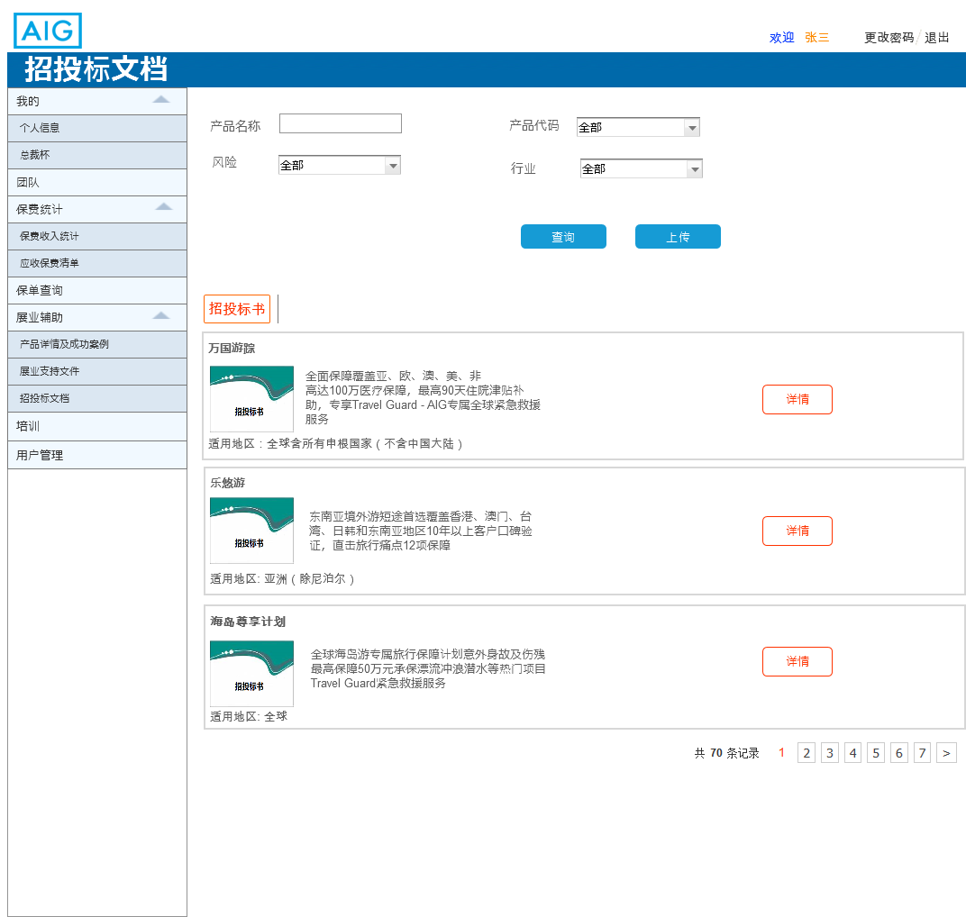
7.5.3.2_1 biding documents page

Field Specifications
Field Name | Type | Dropdown List Content | Attribute (Editable/Read Only) | Remark
产品名称 | Text | NA | Editable | Product name
产品代码 | Dropdown list | AIG provide | Editable | Product code
行业 | Dropdown list | AIG provide | Editable | Industry
风险 | Dropdown list | AIG provide | Editable | Risk

Online Training

Sub Function 1: Online Training

Sub Function Name | Online training
Brief Description | This sub function enables the user to open online training.
Actor(s) | user
Pre-Conditions | Actor access to online training page.
Flow of Events | Normal Flow:
Flow of Events | - When actor login in intranet and click “培训”in menu, the training page will display.  - After actor click training link, training materials will display.  - The flow end.
Flow of Events | Alternate Flow / Exceptions:
Flow of Events | Alternative flow 1: If. user in extranet  - When actor login China Distribution Portal in extranet.  - After actor click “培训” in menu, training page will display.  - Actor could only view the online training list.
Flow of Events | Extensions:
Flow of Events | None
Post-Condition | Actor open online training successfully.

Business Rules
- <Training> page will contain a training list. Training list displays ten records at most. All records are sorted according to the latest upload time After the user clicks the training name, the corresponding learning page is popped up on the page.

- Distribution Portal shall display training materials in Intranet environment, the training materials should not be allowed to be downloaded or shared to others. The portal distinguishes between intranet and extranet through gateways. The portal will detect the segment address of the login user if it belongs to the company's internal network. Users could view and enquiry online training. If the user in extranet, he/she could only view the online training list.

UI
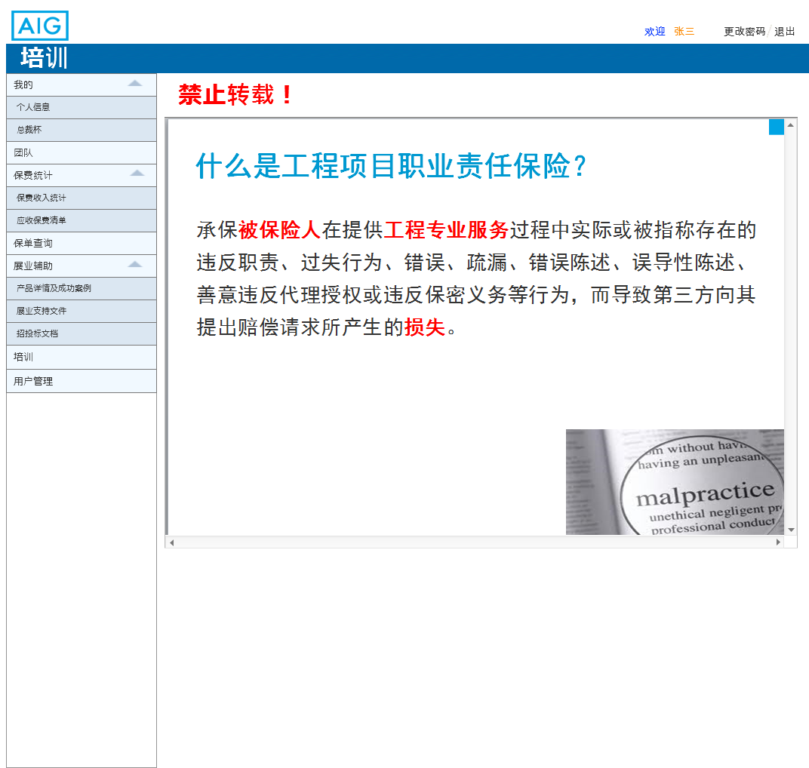
7.6.2.2_1 training page

Field Specifications
NA

Management & Statistic uploading

Sub Function 1: User management

Sub Function Name | User management
Brief Description | This function is for Admin user to use. He/she could use this function to edit employee user info, or account status.
Actor(s) | Admin
Pre-Conditions | Some users have been registered at Distribution Portal.
Flow of Events | Normal Flow:
Flow of Events | Normal Flow: Active new user.  - After someone registered at Distribution Portal, an automatic email will be sent to Admin.  - Admin could login the Portal and open “User Management” module to search the user.  - He/she could query a user by some criteria and click [search] button.  - After search, a user list will display below the query criteria part.  - Admin could choose one user record and the [edit] action.  - After that, <Employee information> page will pop up.  - Admin should input “position” & “producer sub code” & “Producer code” & “assistant” and change the account status from “inactive” to “active”.  - When Admin clicks [complete] button, the portal will check if there has any error. If not any error, the user status will be updated into DB.  - Meanwhile, the Portal will trigger an email and send to the user.  - The Flow End.
Flow of Events | Alternate Flow / Exceptions:
Flow of Events | Alternative flow 1: Edit employee info.  - When any user needs to edit their information, he/she needs to contact Admin offline.  - Admin could login the Portal and open “User Management” module to search the user.  - He/she could query a user by some criteria and click [search] button.  - After search, a user list will display below the query criteria.  - Admin could choose one user record and click the [edit] action.  - After that, <employee information> page will pop up. And then, Admin could edit the employee information.  - When finish, Admin could click [complete] button. The portal will check if there has any error  - If nothing wrong here, the edited information will be updated into DB. And Portal will trigger an email send to the user. Meanwhile, the <employee information> page will be closed directly.  - The flow end.  Alternative Flow 2: Create a user.  - Admin could login the Portal and open “User Management” module, and then click [ Create a new user].  - <employee information> page will pop up with blank fields.  - After Admin insert the information and click [complete], the user status will be updated into DB. But the user status will be inactive.  - Then Admin also need active this account.  - After active the account, the Portal will trigger an email and send to the user.  - The Flow End.
Flow of Events | Extensions:
Flow of Events | None
Post-Condition | User status and information will be updated into DB.

Business Rules

- <User management > page will contain a query criteria part and a user list. When user open this page, user list will display all user records and sort by employee No. Each page should display 20 records. Page details are as below:
  - Query Criteria including:
    - Name
    - Brach: drop down list. Content is: 上海分公司/广东分公司/深圳分公司/北京分公司/江苏分公司/浙江分公司
    - Employee No
  - User list include user info and actions.
    - User info including: Account id/ name/ branch/ position/ employee no.
    - Actions:
      - [Edit] action is enable for all records. After user click this action, <employee info> page will pop up and display the employee info.
      - After user status or employee info has been update, the Portal will trigger an email to the nominated user.
    - Create a new user: When Admin clicks this button, <employee info> page will pop up with blank fields. He/she could register an account instead of some user.

- <Employee info> page please refer to UI. The result list should be paging by 10 records and sort by “create date & time” from the latest to the farthest.

- Admin could choose one record and click [edit] to open this page with the nominated user’s information. Or Admin could click [create a new user] to open this page with blank fields.

- When Admin user want to active a user, they need choose the record and click [edit]. After that, he/she could view the employee’s information and there are some fields need input by Admin user:
  - Position: Admin need choose one position for every user.
  - producer sub code: If the employee’s team is “ADD” & “CBE”, Admin need input this field.
  - Producer code: If the employee’s team is “DS”, Admin need input this field.
  - Assistant’ employee id: if the employee is managed by one assistant, Admin need input the assistant’s employee id here.
  - Status need be changed from “inactive” to “active”.

- After Admin clicks [complete] button on <Employee info>, the portal will check rules as below.
  - If any mandatory field is null, there will display an error like “请输入XXX” XXX should be the field’s name.
    - Mandatory fields including: account id/ name/ position/ employee no/ contact no/ email account/ status/ agent qualification no.
    - Conditional mandatory fields:
      - When team is “ADD” or “CBE”, producer sub code is mandatory.
      - When team is “DS”, producer code is mandatory.
      - When position is “CDO/ OP manager/ Branch GM”, team field is optional. Other position, the team field is mandatory.
      - When position is “CDO/ OP manager”, branch field is optional. Other position, the branch field is mandatory.
    - Optional field:
      - Assistant’ employee id: Only when the employee is managed by assistant, this field need be input.
  - If email or contact no. field is wrong format, there will display an error like “请按正确的格式填写”
  - If DB has another record has the same account id with this one, there will display an error like “已存在该用户名”
  - If DB has another record has the same employee no with this one, there will display an error like “该员工号已存在账号”
  - Only when there is no error, the information will be insert/updated into DB, and an message will pop up like “ 保存成功。”

- There will have 3 emails triggered by different actions, details are as below. After the trigger point, the Portal will create an email record. When the email has successfully sent out, it will be marked as “success”. If the email fail to send, it will be marked as “failed”. The portal will run a batch to resend all failed records one by one at midnight every day (configurable).
  - Active an account
    - Trigger point: After user click [complete] button on <Employee information> and pass all check rules. Once the portal update the “status” from “inactive” to “active”, then it will trigger this email. (Which means, if Admin edit employee info and update the status to “active” at the same time, the portal will trigger this email.)
    - From:
    - To: the nominated user’s email address
    - CC:
    - Subject: [Distribution portal] Account has been activated
    - Content:
Your Distribution portal account has been activated, please user your initial password to login. For your account security, please change your password immediately after login.

Account ID | Initial password
 | Password!

- Inactive an account, then trigger an email.
- Trigger point: after user click [complete] button on <Employee information> and pass all check rules. Once the portal update the “status” from “active” to “inactive”, then it will trigger this email.
    - From:
    - To: the nominated user’s email address
    - CC:
    - Subject: [Distribution portal] Account has been inactivated
    - Content:
Your Distribution portal account has been inactivated.
If any problem, please contact Admin.

- Employee information updated email
- Trigger point: after user click [complete] button on <Employee information> and pass all check rules. If the portal update the user record without update the “status” field, then it will trigger this email.
- From:
- To: the nominated user’s email address
- CC:
- Subject: [Distribution portal] Account information has been updated
- Content:
Your Distribution Portal account information has been updated, you can login Distribution Portal and review your employee information.
If any problem, please contact Admin.

UI
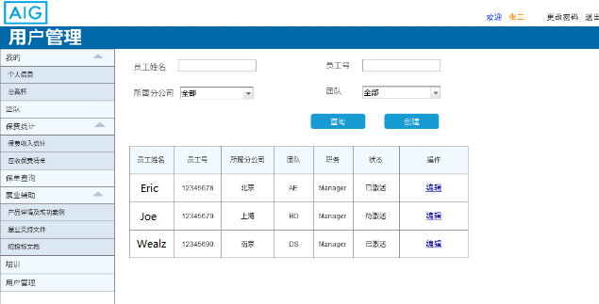

After click [edit], the portal will display below page.
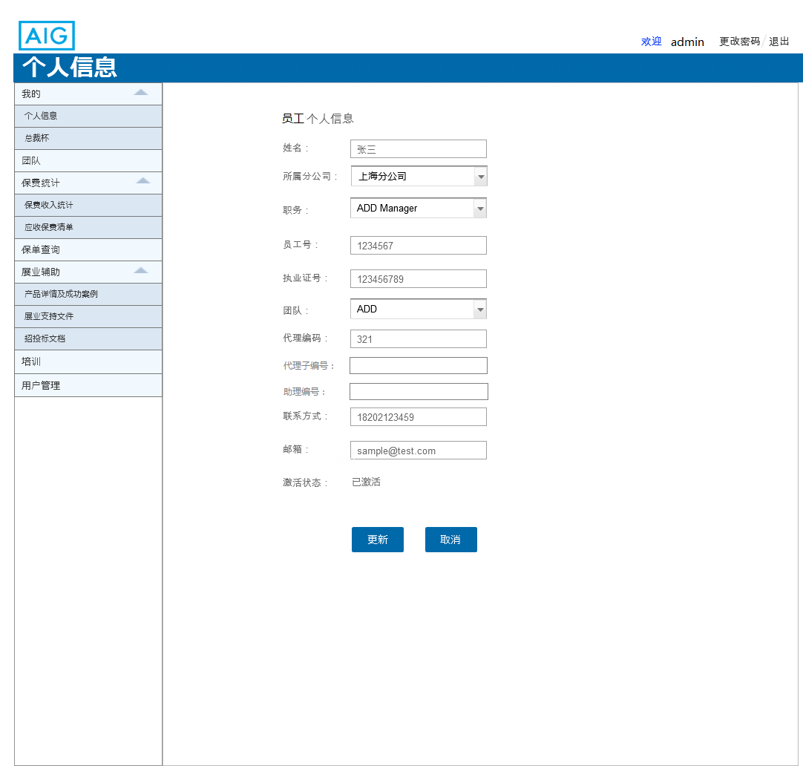

Field Specifications
Field Name | Type | Dropdown List Content | Mandatory | Attribute (Editable/Read Only) | Validation | Remark
用户名 | Text | NA | Yes | Editable | 50个字符内的中文或英文 | Account ID
姓名 | Text | NA | Yes | Editable | 10个字符内的中文或英文 | Name
所属分公司 | Dropdown list | 上海分公司/广东分公司/深圳分公司/北京分公司/江苏分公司/浙江分公司 | Yes | Editable |  | Branch
职务 | Dropdown list | 职员/ 组长/ 组长助理/ 分公司经理/ CHO/CDO/OP Manager/ 管理员 | Yes | Editable |  | Position
员工号 | Text | NA | Yes | Editable | 10个字符内的数字 | Employee No.
联系方式 | Text | NA | Yes | Editable | 手机号校验 | Contact No.
邮箱 | Text | NA | Yes | Editable | 邮箱格式校验 | Email account
注册 | Button | NA | NA | Read Only |  | Submit
执业证号 | Text | NA | Conditional mandatory | Editable |  | Agent qualification No.
团队 | Dropdown list | ADD/DS/CBE | Conditional mandatory | Editable | Optional for CDO/CHO/Op manager/Branch GM | Team

Sub Function 2: Notification Management

Sub Function Name | Notification Management
Brief Description | Admin could create/ delete/enable /disable notifications at this module
Actor(s) | Admin
Pre-Conditions | User login the Distribution Portal
Flow of Events | Normal Flow:
Flow of Events | - After Admin click [Create] button on <notification management> page, < create new notification> will display.  - Admin need input notification title and upload a Link of notification, and then click [confirm]button to submit.  - After a new notification is created, a record will display in notification list.  - Admin could perform [delete], [enable], [disable] action to this record.  - The flow ends.
Flow of Events | Alternate Flow / Exceptions:
Flow of Events | N/A
Flow of Events | Extensions:
Flow of Events | None
Post-Condition

Business Rules
- <Notification management > page including a notification list. Each created notification will display in the list. Admin user could perform [delete], [enable], [disable] action to each record. User also could click [create] button to create new notification.

- On < Create new notification> page, user should input “title” and the link of notification. When user click [confirm], the portal will reserve notification information including: title, link, update date & time, status and update user. Then < Create new notification> page will be closed automatically and an message will pop up like “ 保存成功。” . User could found the created record in notification list.

- The result list should be paging by 10 records and sort by “Update date & time” from the latest to the farthest.

- After user click [delete] button of one record, a box will pop up asking user “是否要删除这条信息？” if user select yes, the information will be deleted. If user select no, the information will not be deleted.

- After user click [enable] button of one record, the portal will check if the enabled records exceed 5 records.
  - If exceed 5 records, the portal should pop up an error like “ 至多支持同时显示5条通知”. And the status of the record will not be updated to “enabled”
  - Only when the enabled records are less than 5 records, the portal will update the status to “enabled” directly.

- After user click [disable] button of one record, the record status will be updated to “disabled”.

- All enabled records will display as scroll bar at overview page. Time interval between 2 notifications is 3 seconds (configurable). Display sequence should be based on the updating date & time. The nearest one will at the first sequence.

UI
UI provided by AIG
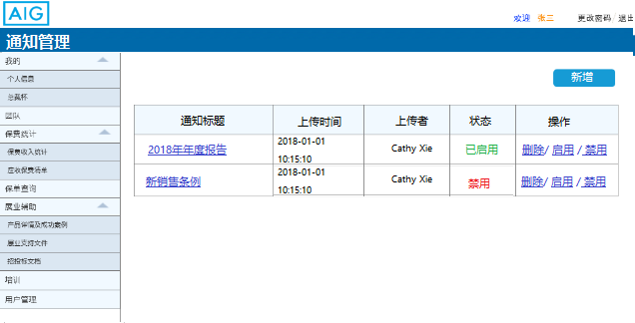

Click[Create] button, bellow page will display.
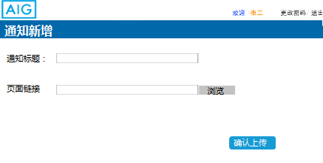

Field Specifications
N/A

Sub Function 3: President Conference campaign uploading

Sub Function Name | President Conference campaign uploading
Brief Description | Admin user or assistant could use this module to upload president conference campaign statistics.
Actor(s) | Admin user or assistant user
Pre-Conditions | User login the distribution portal.
Flow of Events | Normal Flow:
Flow of Events | - At <President conference campaign uploading> page, Admin could download a template for uploading.  - After Admin click [upload] button, < PCC New uploading> will display.  - Admin need input the “Cut-off date” and upload an excel, and then click [upload]button to submit.  - The portal will check if the “cut-off date” of this new record is earlier or equal to the latest record in DB.  - After a new record is uploaded, a record will display in president conference campaign list.  - If Admin want to view historical data, he/she could perform [download] action to this record.  - The flow ends.
Flow of Events | Alternate Flow / Exceptions:
Flow of Events | NA
Flow of Events | Extensions:
Flow of Events | None
Post-Condition

Business Rules
- < President Conference campaign uploading> page including one query criteria which is “cut-off date”, one [Search] button, one [Download template] button and an updated list. After every uploading, the portal will add a record into the list. Admin user could perform [Download] action to each record. User also could click [upload] button to open <PCC new uploading>page for uploading a bulk data of president conference campaign.

- Download template and template rules are as below：

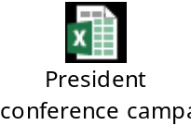

- On <PCC New uploading > page, user should input “Cut-off date” and upload an excel. When user click [create], the portal checks below rules:
  - If the “cut-off date” of this new record is earlier than or equal to the latest record in DB.
    - If it is, the portal will pop up an error like “该截止时间已存在，请输入最新的截止时间”
    - If it is not, pass this rule.
  - If the upload file’s title is same as “President Conference campaign” table in DB.
    - If it is not, the portal will pop up an error like “文档格式错误，请使用正确的格式模板”
    - If it is, pass this rule.
  - If the file data is follow the template rules:
    - If it is not, the portal will pop up an error like “文档数据格式错误，请使用正确的格式”
    - If it is, pass this rule.
  - If the uploading file has one record’s “employee id” is totally same as another record in uploading file.
    - If it is not, the portal will pop up an error like “存在重复数据，请检查。”
    - If it is, pass this rule.
  - After pass all rules, the portal will reserve information into DB and create an uploaded record. The record will include information like: cut-off date, update date & time and update user. <PCC New uploading > page will be closed automatically and an message will pop up like “ 上传成功。” User could found the uploaded record in result list.

- The result list should be paging by 10 records and sort by “cut-off date” from the latest to the farthest.

- When user click the [download] button of one record, the portal will download all data which “cut-off date” is same as the specified record. The download format is Excel.

UI

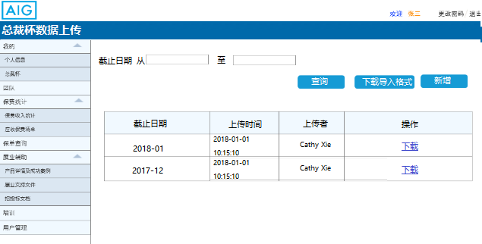

Click[Create] button, bellow page will display.

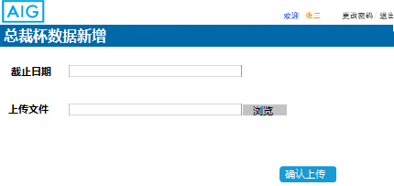

Field Specifications
Field Name | Type | Dropdown List Content | Mandatory | Attribute (Editable/Read Only) | Validation | Remark
截止日期 | Text | NA | No | Editable | YYYY/MM/DD | Cut off date

Sub Function 4: Submission Statistics uploading

Sub Function Name | Submission Statistics uploading
Brief Description | Admin user or assistant could use this module to upload submission statistics.
Actor(s) | Admin user or assistant user
Pre-Conditions | User login the distribution portal.
Flow of Events | Normal Flow:
Flow of Events | - At < Submission Statistics uploading> page, Admin could download a template for uploading.  - After Admin click [create] button, <Submission statistics New uploading> will display.  - Admin need input upload an excel, and then click [create] button to submit.  - The portal will check if the file could be uploaded.  - After a new record is uploaded, a record will display in Submission statistics list.  - If Admin want to view historical data, he/she could perform [download] action to this record.  - The flow ends.
Flow of Events | Alternate Flow / Exceptions:
Flow of Events | N/A
Flow of Events | Extensions:
Flow of Events | None
Post-Condition

Business Rules

- < Submission Statistics uploading> page including: One [Search] button, one [Download template] button and an updated list. After every uploading, the portal will add a record into the list. Admin user could perform [Download] action to each record. User also could click [create] button to open <Submission statistics new uploading>page for uploading a bulk data of Submission statistics

- Download template and template rules are as below：



- On < Submission Statistics New uploading > page, user should upload an excel. When user click [upload], the portal checks below rules:
  - If the upload file’s title is same as “Submission Statistics” table in DB.
    - If it is not, the portal will pop up an error like “文档格式错误，请使用正确的格式模板”
    - If it is, pass this rule.
  - If the file data is follow the template rules:
    - If it is not, the portal will pop up an error like “文档数据格式错误，请使用正确的格式”
    - If it is, pass this rule.
  - If the uploading file has one record’s “employee id” + “Policy no.” is totally same as another record in uploading file.
    - If it is not, the portal will pop up an error like “存在重复数据，请检查。”
    - If it is, pass this rule.
  - If DB has one record’s “employee id” + “Policy no.” is totally same as one record in uploading file.
    - If it is not, the portal will pop up an error like “存在重复数据，请检查。”
    - If it is, pass this rule.
  - After pass all rules, the portal will reserve information into DB and create an uploaded record. The record will include information like: Update date & time and update user. Then < Submission Statistics New uploading > page will be closed automatically. User could found the uploaded record in result list.

- The result list should be paging by 10 records and sort by “Update date & time” from the latest to the farthest.

- When user click the [download] button of one record, the portal will download all data which “Update date & time” is same as the specified record. The download format is Excel.

UI
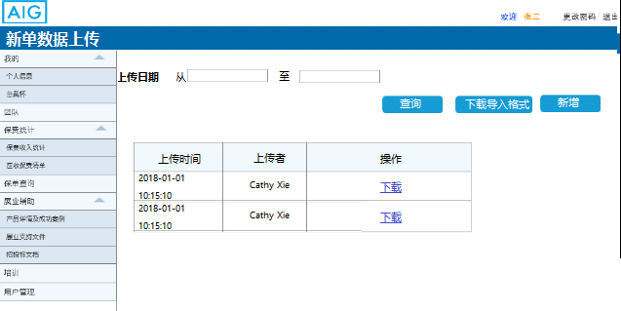

Click[Create] button, bellow page will display.

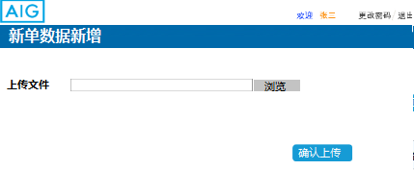

Field Specifications
Field Name | Type | Dropdown List Content | Mandatory | Attribute (Editable/Read Only) | Validation | Remark
上传日期 | Text | NA | No | Editable | YYYY/MM/DD | Upload date

Sub Function 5: Premium receivable list uploading

Sub Function Name | Premium receivable uploading
Brief Description | Admin user or assistant could use this module to upload premium receivable list.
Actor(s) | Admin user or assistant user
Pre-Conditions | User login the distribution portal.
Flow of Events | Normal Flow:
Flow of Events | - At < Premium receivable list uploading> page, Admin could download a template for uploading.  - After Admin click [create] button, < Premium receivable list New uploading> will display.  - Admin need upload an excel, and then click [create] button to submit.  - The portal will check if the file could be uploaded.  - After a new record is uploaded, a record will display in uploaded list.  - If Admin want to view historical data, he/she could perform [download] action to this record.  - The flow ends.
Flow of Events | Alternate Flow / Exceptions:
Flow of Events | N/A
Flow of Events | Extensions:
Flow of Events | None
Post-Condition

Business Rules
- < Premium receivable list uploading> page including: One [Search] button, one [Download template] button and an updated list. After every uploading, the portal will add a record into the list. Admin user could perform [Download] action to each record. User also could click [create] button to open < Premium receivable list new uploading>page for uploading a bulk data of Premium receivable list.

- Download template and template rules are as below：
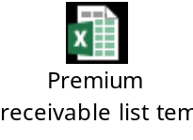

- On < Premium receivable list New uploading > page, user should upload an excel. When user click [upload], the portal checks below rules:
  - If the upload file’s title is same as “Premium receivable list” table in DB.
    - If it is not, the portal will pop up an error like “文档格式错误，请使用正确的格式模板”
    - If it is, pass this rule.
  - If the file data is follow the template rules:
    - If it is not, the portal will pop up an error like “文档数据格式错误，请使用正确的格式”
    - If it is, pass this rule.
  - If the uploading file has one record’s “employee id” + “master policy no.” + “policy no.” is totally same as another record in uploading file.
    - If it is not, the portal will pop up an error like “存在重复数据，请检查。”
    - If it is, pass this rule.
  - If DB has one record’s “employee id” + “master policy no.” + “policy no.” is totally same as one record in uploading file.
    - If it is not, the portal will pop up an error like “存在重复数据，请检查。”
    - If it is, pass this rule.
  - After pass all rules, the portal will reserve information into DB and create an uploaded record. The record will include information like: Update date & time and update user. Then < Premium receivable list New uploading > page will be closed automatically. User could found the uploaded record in result list.

- The result list should be paging by 10 records and sort by “Update date & time” from the latest to the farthest.

- When user click the [download] button of one record, the portal will download all data which “Update date & time” is same as the specified record. The download format is Excel.

UI

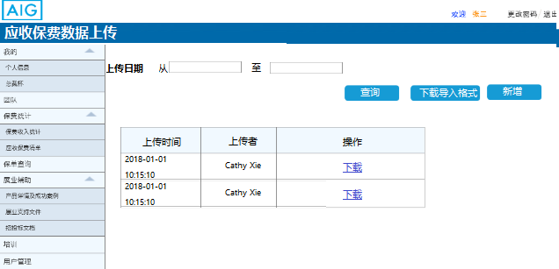

Click[Create] button, bellow page will display.

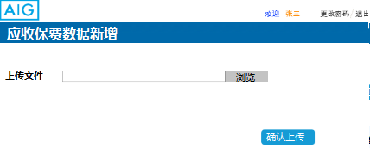

Field Specifications
Field Name | Type | Dropdown List Content | Mandatory | Attribute (Editable/Read Only) | Validation | Remark
上传日期 | Text | NA | No | Editable | YYYY/MM/DD | Upload date

Sub Function 6: Product & Successes story uploading
Sub Function Name | Product & success story uploading page
Brief Description | This sub function enables the user to upload product information.
Actor(s) | Admin user
Pre-Conditions | Actor access to admin page.
Flow of Events | Normal Flow:
Flow of Events | - When the actor access to this module, they could upload product information link, success story link and certificate template.  - If actor click [upload] button, the portal will check if all information has been upload completely  - If check pass, success message will display. Otherwise, error message will display.
Flow of Events | Alternate Flow / Exceptions:
Flow of Events | Alternative flow 1: If. delete information  - When the actor access to admin console, they could delete product information link, success story link and certificate template.  - If actor click [delete] button beside product information, the product information will be deleted.  - After deleted, success message will display. Otherwise, error message will display.  Alternative flow 2: If. enable/disable information  - When the actor access to admin console, they could enable/disable product information link, success story link and certificate template.  - If actor click [enable] button beside product information, the product information will be enable.  - When click successful, normal user page will be able to see this information.  - If actor click [disable] button beside product information, the product information will be disable.  - When click successful, normal user page will be disable to see this information.  - After modifying the information state, the portal will display successful message.
Flow of Events | Extensions:
Flow of Events | None
Post-Condition | Actor can upload product information successfully.

Business Rules
- When admin user clicks [update]button in < Product & success story uploading page > page, the <update product> page will display. When users fill in information, they need to comply with the following requirements:
- When users enter “产品名称” in the input box, the word number is restricted to 50 characters. If the number of characters exceeds the limit, input will be disabled.
- When users click [上传产品图片]button, the portal will open the local folder. The image format is JPEG/PNG, size limited to 2M. After the upload is successful，the preview will be displayed.
- When users enter “产品详情概述” in the input box, the word number is restricted to 300 characters. If the number of characters exceeds the limit, input will be disabled.
- Users could select some “tags” such as LOB, product name, risk for the product. Each tags are drop down list for user to select.
- When users click [上传产品详情]button, the portal will open the local folder. The file format is PDF. If update successful, the portal will display upload path and success message like “上传成功”. Else the portal will display an error message like “上传失败”.
- When users click [上传保单凭证]button, the portal will open the local folder. The file format is PDF. If update successful, the portal will display upload path and success message like “上传成功”. Else the portal will display an error message like “上传失败”.
- If user click [确认]button, the portal will check if all information is correct. If check pass, information will update to DB. Rules as below:
- If any field enter blank, the portal will display an error like “请输入XXX”. XXX is the field name.
- If the product name is duplication, the portal will display an error like “上传信息重复，请重新上传”.

- If user click [delete] button in <admin >page, a box will pop up asking user “是否要删除这条信息？” if user select yes, the information will be deleted. If user select no, the information will not be deleted.

- [enable/disable] button default is enable; product details’ status is enable. After user click this button, button become disable and product details’ status are disable.

- User could upload success story links and select some tags. When admin user clicks [update]button in <story admin> page, <update success story>page will display.
- When users enter “成功故事名称” in the input box, the word number is restricted to 50 characters. If the number of characters exceeds the limit, input will be disabled. If enter blank, the portal will display an error like “请输入成功故事名称”.
- When users enter “故事详情概述” in the input box, the word number is restricted to 300 characters. If the number of characters exceeds the limit, input will be disabled. If enter blank, the portal will display an error like “请输入故事详情概述”.
- When users click [上传PDF] button, the portal will open the local folder. The file format is PDF. If update successful, the portal will display upload path and success message like “上传成功”. Else the portal will display an error message like “上传失败”.
- If user click [确认]button, the portal will check if all information is correct. If check pass, information will update to DB.
- If any field enter blank, the portal will display an error like “请输入XXX”. XXX is the field name.
- If the product name is duplication, the portal will display an error like “上传信息重复，请重新上传”.

UI
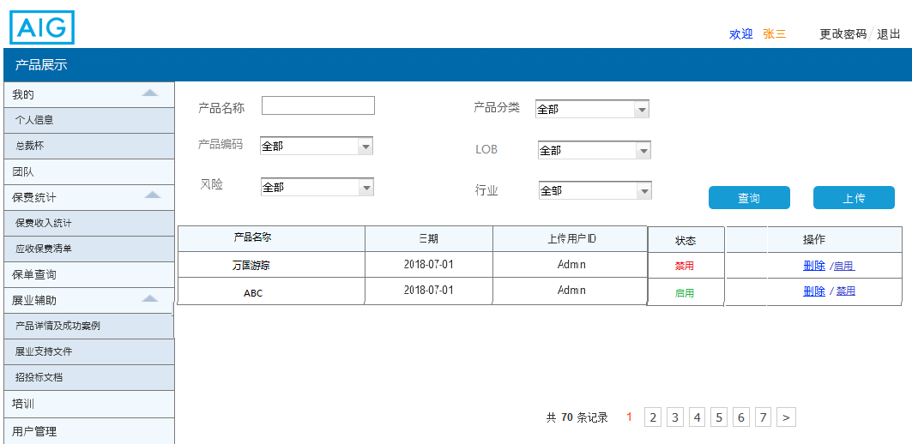
7.4.1.2_1 admin page
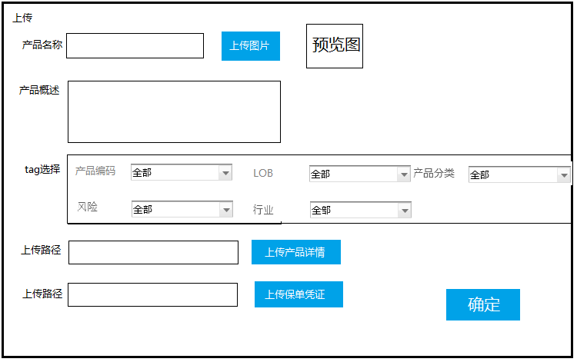
7.4.1.2_2 update product page
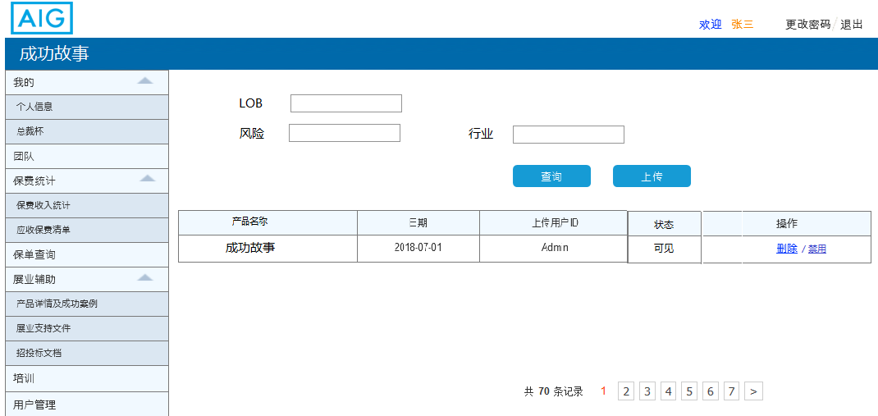
7.4.1.2_3 story admin page
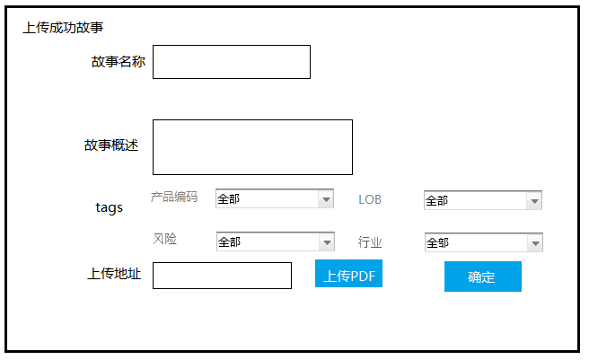
7.4.1.2_4 update success story page

Field Specifications
Field Name | Type | Dropdown List Content | Attribute (Editable/Read Only) | Remark
产品名称 | Text | NA | Editable | Product name
产品分类 | Dropdown list | AIG provide | Editable | Product category
产品编码 | Dropdown list | AIG provide | Editable | Product code
产品概述 | Text | NA | Editable | Product outline
产品详情上传路径 | Text | NA | Editable | Path1
保单凭证上传路径 | Text | NA | Editable | Path2
成功故事上传路径 | Text | NA | Editable | Path3
成功故事名称 | Text | NA | Editable | Story name
故事概述 | Text | NA | Editable | Story outline
LOB | Dropdown list | AIG provide | Editable | Lob
Tags | Dropdown list | AIG provide | Editable | Tag
行业 | Dropdown list | AIG provide | Editable | Industry
风险 | Dropdown list | AIG provide | Editable | Risk

Sub Function 7: Sales support document uploading
Sub Function Name | Uploading page
Brief Description | This sub function enables the user to upload product information.
Actor(s) | Admin user
Pre-Conditions | Actor access to sale practices admin page.
Flow of Events | Normal Flow:
Flow of Events | - When the actor access to sale practices admin page, they could upload the Company qualification material, Company introduction material, Promotion video or Bidding documents.  - If actor click [upload] button, the portal will check if all information has been upload completely  - If check pass, success message will display. Otherwise, error message will display.
Flow of Events | Alternate Flow / Exceptions:
Flow of Events | Alternative flow 1: If. delete information  - When the actor access to sale practices admin page, they could delete the Company qualification material, Company introduction material, Promotion video or Bidding documents.  - If actor click [delete] button beside product information, the product information will be deleted.  - After deleted, success message will display. Otherwise, error message will display.  Alternative flow 2: If. enable/disable information  - When the actor access to sale practices admin page, they could enable/disable the Company qualification material, Company introduction material, Promotion video or Bidding documents.  - If actor click [enable] button beside product information, the product information will be enable.  - When click successful, normal user page will be able to see this information.  - If actor click [disable] button beside product information, the product information will be disable.  - When click successful, normal user page will be disable to see this information.  - After modifying the information state, the portal will display successful message.
Flow of Events | Extensions:
Flow of Events | None
Post-Condition | Actor upload product details to other successfully.

Business Rules
- Admin user could upload/delete/disable/enable the Company qualification material, Company introduction material, Promotion video, Bidding documents.

- < sale practices admin > will contain four part: Company qualification material, Company introduction material, Promotion video and Bidding documents. Users can search corresponding documents through time and sales practice name. Each part displays up to 3 links, showing the total number of links below each part.
- Company introduction material
- Company qualification material
- Promotion video
For above 3 types, when user click [upload]button, the portal will open an upload page refer to UI. When user click [上传PDF], the portal will open the local folder and let the user choose the upload path. After upload success, the portal will display success message like “上传成功”. After the upload is successful, the file name link will be displayed. Else the portal will display an error like “上传失败”. The file format is PDF. If there is a company introduction, it will not be uploaded. User can only choose to delete or edit.
- Bidding documents
- After users click [upload]button, upload bidding document page will display.
- When users enter “投标书名称” in the input box, the word number is restricted to 50 characters. If the number of characters exceeds the limit, input will be disabled.
- When users click [上传]button, the portal will open the local folder. The file format is PDF.
- When users enter “投标概述” in the input box, the word number is restricted to 300 characters. If the number of characters exceeds the limit, input will be disabled. I
- User could select some tags when upload.
- If user click [确认]button, the portal will check if all information is correct. If check pass, information will update to DB.
- If any field enter blank, the portal will display an error like “请输入XXX”. XXX is the field name.
- If the product name is duplication, the portal will display an error like “上传信息重复，请重新上传”.
If update successful, the portal will display success message like “上传成功”. Else the portal will display an error message like “上传失败”.

- If user click [delete] button in < sale practices admin >page, a box will pop up asking user “是否要删除这条信息？” if user select yes, the information will be deleted. If user select no, the information will not be deleted.

- [enable/disable] button default is enable; product details are enable. After user click this button, button become off and product details are disable. After modifying the information state, the portal will display successful message like “修改成功”.

UI
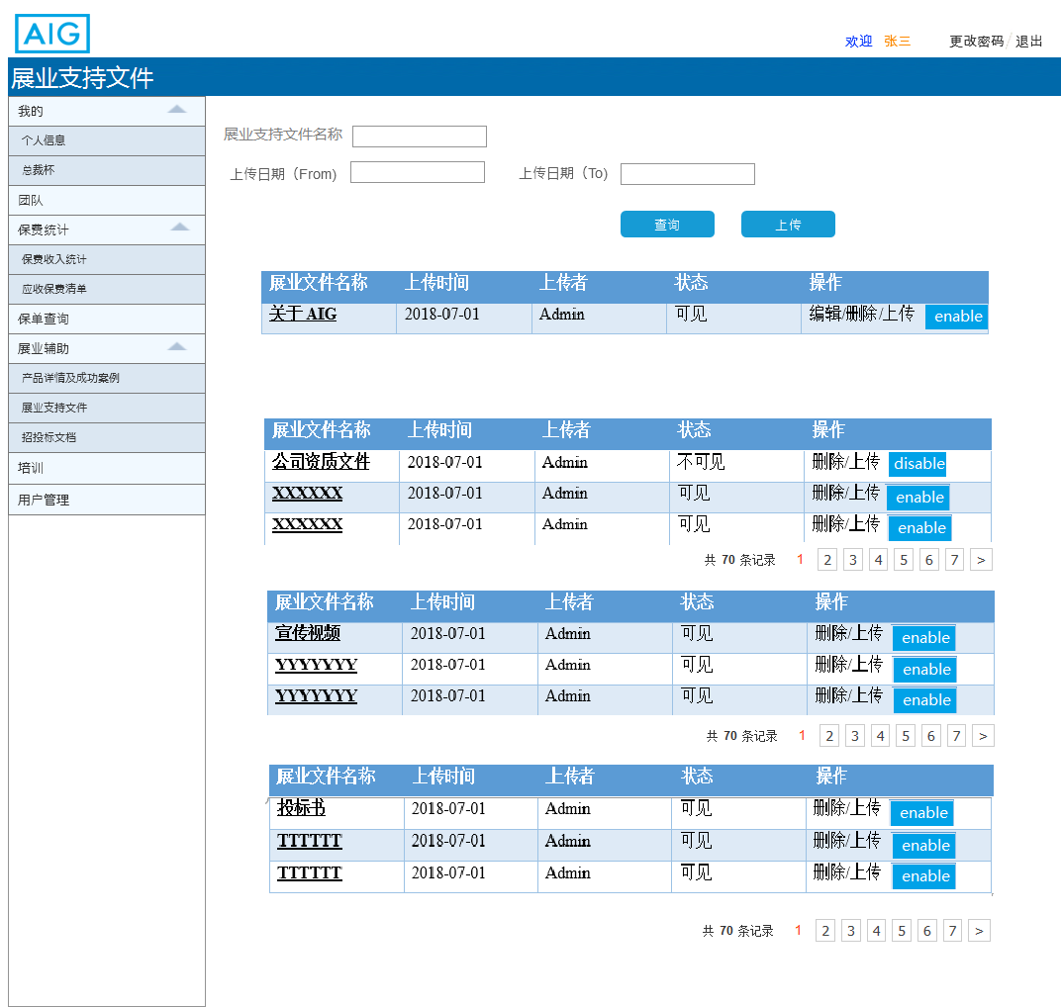
7.5.1.2_1 sale practices admin page
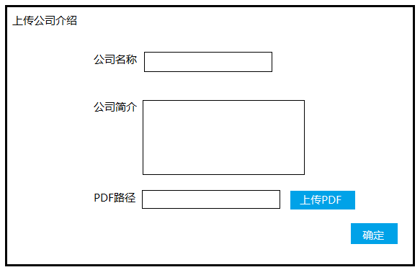
7.5.1.2_2 update introduction page

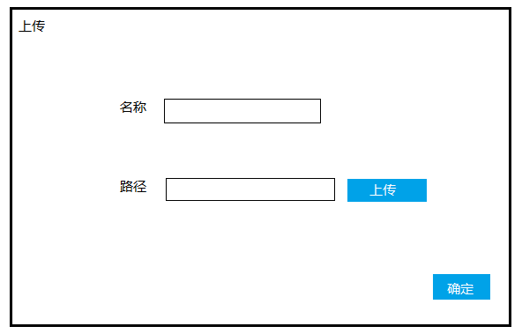
7.5.1.2_3 update material page
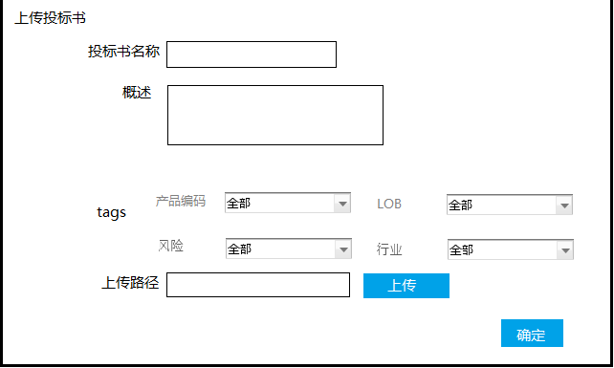
7.5.1.2_4 update bidding document page

Field Specifications
Field Name | Type | Dropdown List Content | Attribute (Editable/Read Only) | Remark
展业支持文件名称 | Text | NA | Editable | Document name
上传时间（from） | Text | NA | Editable | Time from
上传时间（to） | Text | NA | Editable | Time to
公司名称 | Text | NA | Editable | Company name
公司简介 | Text | NA | Editable | Introduction
PDF路径 | Text | NA | Editable | Path4
名称 | Text | NA | Editable | Material name
路径 | Text | NA | Editable | Path5
投标书名称 | Text | NA | Editable | Tbname
概述 | Text | NA | Editable | Bidding outline
Tags | Text | NA | Editable | Tag
上传路径 | Text | NA | Editable | Path6

Sub Function 8: Online training uploading
Sub Function Name | Upload page
Brief Description | This sub function enables the user to upload online training information.
Actor(s) | Admin user
Pre-Conditions | Actor access to upload page.
Flow of Events | Normal Flow:
Flow of Events | - When the actor access to online admin page, they could upload the training links.  - If actor click [upload] button, the portal will upload training link. If upload successfully, success message will display. Otherwise, error message will display.
Flow of Events | Alternate Flow / Exceptions:
Flow of Events | Alternative flow 1: If. delete training links  - When the actor access to training admin page, they could delete the training links.  - If actor click [delete] button beside training links, the training links will be deleted.  - After deleted, success message will display. Otherwise, error message will display.  Alternative flow 2: If. enable/disable training links  - When the actor access to training admin page, they could enable/disable the training links  - If actor click [enable] button beside training links, the training links will be enable.  - When click successful, normal user page will be able to see this information.  - If actor click [disable] button beside training links, the training links will be disable.  - When click successful, normal user page will be disable to see this information.  - After modifying the online training state, the portal will display successful message.
Flow of Events | Extensions:
Flow of Events | None
Post-Condition | Actor upload online training information successfully.

Business Rules
- Admin user could upload/delete/disable/enable the online training links.

- < training admin > will contain an inquiry criteria part an online training list. Each list displays ten records at most. All records are sorted according to the latest upload time. Page details are as below:
  - Query Criteria including:
    - online cause name
    - upload date(from)
    - upload date(to)
  - User list include user info and actions.
    - Online training info including: online cause name/date/ upload user id/operation
    - Actions:
      - [查询] action is enable for all records. After user click this action, the the portal matches the results according to the input criteria.
      - [上传] action is enable for all records. After user click this action, < upload> page will pop up.
      - [delete] action is enable for all records. After user click this action, the the portal will delete the link.
      - [enable] action is enable for all records. After user click this action, normal user will view the training link.
      - [disable] action is enable for all records. After user click this action, the the portal will hide this link and normal user will cannot view the training link.
- If user click[上传]button, upload page will display. Upload page refer to UI.
- After users click [upload]button, upload link page will display.
- When users enter “课程名称xxxxx” in the input box, the word number is restricted to 50 characters. If the number of characters exceeds the limit, input will be disabled. If enter blank, the portal will display an error like “请输入课程名称”.
- User should upload “课程资料” after click[upload].
- If user click [确认]button, the portal will check if all information is correct. If check pass, information will be saved. Course names will be linked to links.

- If user click [delete] button in < training admin >page, a box will pop up asking user “是否要删除这条信息？” if user select yes, the information will be deleted. If user select no, the information will not be deleted.

- [enable/disable] button default is on; product details are enable. After user click this button, button become off and product details are disable. After modifying the information state, the portal will display successful message like “修改成功”.

UI
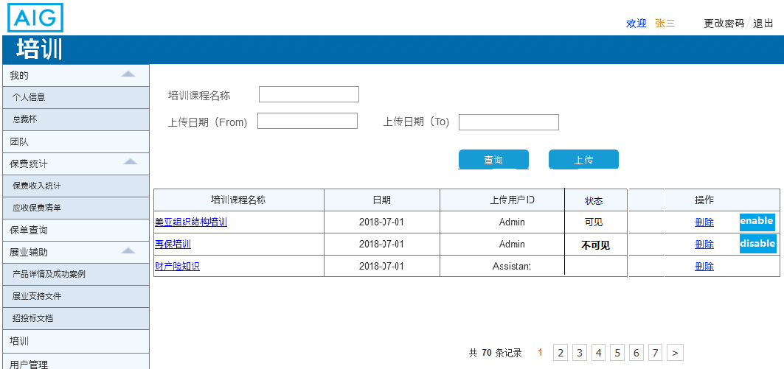
7.6.1.2_1 training admin page
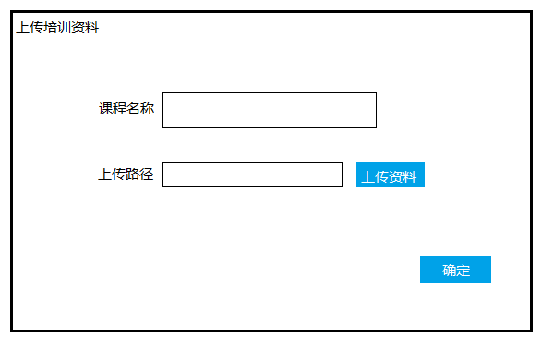
7.6.1.2_2 upload training page

Field Specifications
Field Name | Type | Dropdown List Content | Attribute (Editable/Read Only) | Remark
培训课程名称 | Text | NA | Editable | Training name
上传时间（from） | Text | NA | Editable | Time from
上传时间（to） | Text | NA | Editable | Time to
上传路径 | Text | NA | Editable | Path7

Sub Function 9: Exchange rate setting

Sub Function Name | Exchange rate setting
Brief Description | User could use this module to input the exchange rate between foreign currency to CNY.
Actor(s) | Admin
Pre-Conditions | The user login the distribution portal.
Flow of Events | Normal Flow:
Flow of Events | - When Admin access to this module, an exchange rate list will display on the page.  - The portal will default the exchange rate before the distribution portal launched.  - Admin could use this module to edit the exchange rate.  - After edit, Admin should click [confirm] then the changes will be saved into DB.  - When the portal calculate total premium, total outstanding premium will use the exchange data.
Flow of Events | Alternate Flow / Exceptions:
Flow of Events | Extensions:
Flow of Events | None
Post-Condition

Business Rules
- When Admin access to this module, the exchange rate list will display as below. The rate is the initial default exchange rate.
Exchange From | Exchange To | Rate
USD | CNY | 6.84
EUR | CNY | 7.95
JPY | CNY | 0.062
GBP | CNY | 8.82
HKD | CNY | 0.87

- After user edit the rate, he/she need click [confirm] button. The portal will check if there has any rate is null, if there has, there will pop up an error like “ 汇率不能为空”. If there has not, an message like “ 保存成功” will pop up. The exchange rate will be saved into DB.

- When the portal calculate total premium& total outstanding premium will use the exchange data to trans to CNY.

UI
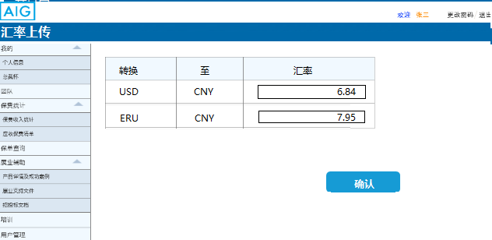

Field Specifications
Field Name | Type | Dropdown List Content | Attribute (Editable/Read Only) | Remark
转换 | Text | NA | Ready only | Currency
至 | Text | NA | Ready only | Standard _Currency
汇率 | Text | NA | Editable | Exchange _rate

Non Functional Specifications

Language
The language is defaulted as simplified Chinese.

Time Zone
The default time zone is GMT +08 for all applications in this project.

Browsers

Platform | browser | version
PC | IE | 11
PC | MS Edge | latest
PC | Firefox | latest
IOS (PAD) | Safari | latest
 | Wechat | latest
IOS (Phone) | Safari | latest
IOS (Phone) | Wechat | latest
Android (PAD) | Chrome | latest
Android (PAD) | Wechat | latest
Android (Phone) | Chrome | latest
Android (Phone) | Wechat | latest

Concurrency
The portal will support at least 20 concurrent users.

Requirement Traceability Matrix
